Capstone Trading Advisors Inc. 830-249-7007

Nat Gas Summary for 6/8/01: We believe that the market is currently in the very latter stages of its ongoing decline. We would ideally expect to see the market move marginally below its previous low at 3.67 in the near term in order to complete this decline. If the market does in fact move to new lows, we expect to encounter good longer-term support in the 3.61 area, and even if it were to get somewhat below here we would be surprised to see it carry much below the 3.50 level. If the market can keep from getting significant follow through in these new lows, as we believe should be the case, then this can begin to set up for a very sizeable short covering rally that we believe should be occurring in weeks to follow (much larger than the one that was recently witnessed).

Support: 3.73 3.67 3.61 3.55 3.52 Resistance: 3.85 4.005 4.175 4.22 4.29

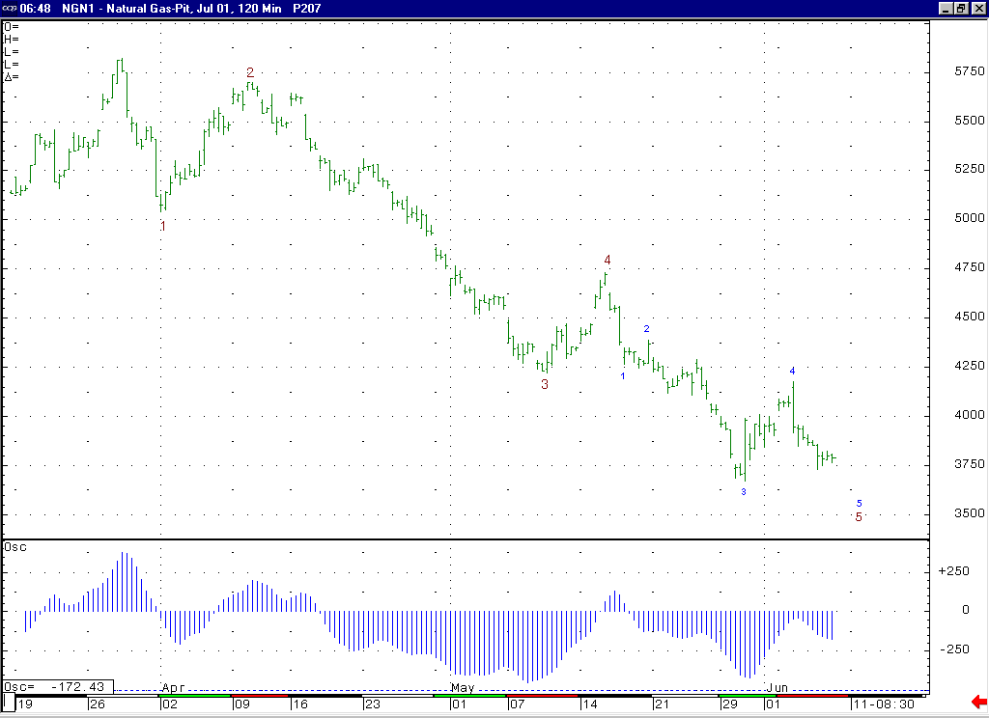
We continue to view the market as most likely being in a wave 5 of the minor degree wave 5 at this time. If this is the case, then first of all this would place the market in the very latter stages of this decline. But it would also call for the market to ideally move down to one more new low in order to complete this decline (unless it were to end in a minor failure).

Technical Discussion: We continue to view the recent weakness off of the 4.73 high as occurring in a minor degree wave 5 position. We also view the recent move up to 4.175 as most likely occurring as the wave 4 of this minor degree wave 5. If this is the case, then we now need only to see the market move down to one more new low in order to complete this minor degree wave 5. If the market can now move into a new low as anticipated, then we would continue to expect it to find good longer term support in the 3.61 area (where a significant swing low was made in July of 2000). Once this minor degree wave 5 has concluded, this should also conclude the larger degree wave 5 (which began from the late March high), which should then conclude the entire drop off of this past winters high. We continue to believe that at some point not too far ahead of us we should see a very sizeable short covering rally that will force the “funds” to bail out of their rather large net short position.

The information herein is believed to be reliable, however Capstone Trading Advisors Inc. does not warrant its completeness or accuracy. The opinions and estimates contained constitute our judgment and are subject to change without notice. Past performance is not indicative of future results. The information contained herein is not intended as an offer or solicitation for the purchase or sale of any financial instrument or commodities. Chart provided with permission from CQG Inc.

