Capstone Trading Advisors Inc. 830-249-7007

Nat Gas Summary for 6/7/01: We believe that it is still possible for the market to move down to challenge, and likely exceed, the recent low at 3.67 in the coming days. If the market does in fact move to new lows, we believe that it will at that point be in the very latter stages of its current decline. Once into these new lows we would expect the market to find very good (longer-term) support in the 3.61 area, and even if this area were exceeded by a small amount we would be surprised to see the market get much below the 3.50 level. We also still believe that the market has a very large short covering rally ahead of it in the weeks to follow (much larger than the one that was recently witnessed).

Support: 3.73 3.67 3.61 3.55 3.52 Resistance: 3.90 4.005 4.175 4.22 4.29

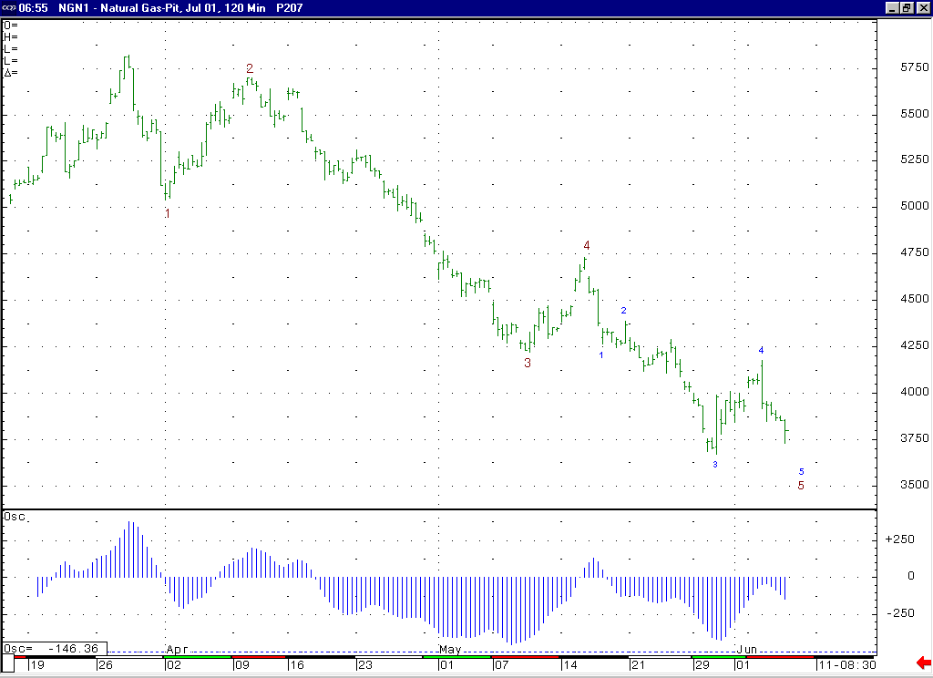
We view this recent move up to 4.175 as most likely occurring as the wave 4 of this minor degree wave 5. If this is the case, then we now need to only see the wave 5 of this minor degree wave 5 carry the market down to one more new low in order to complete this decline.

Technical Discussion: We continue to view the recent weakness off of the 4.73 high as occurring in a minor degree wave 5 position. We also view the recent move up to 4.175 as most likely occurring as the wave 4 of this minor degree wave 5. If this is the case, then we now need only to see the market move down to one more new low in order to complete this minor degree wave 5. If the market can now move into a new low as anticipated, then we would continue to expect it to find good longer term support in the 3.61 area (where a significant swing low was made in July of 2000). Once this minor degree wave 5 has concluded, this should also conclude the larger degree wave 5 (which began from the late March high), which should then conclude the entire drop off of this past winters high. We continue to believe that at some point not too far ahead of us we should see a very sizeable short covering rally that will force the “funds” to bail out of their rather large net short position.

The information herein is believed to be reliable, however Capstone Trading Advisors Inc. does not warrant its completeness or accuracy. The opinions and estimates contained constitute our judgment and are subject to change without notice. Past performance is not indicative of future results. The information contained herein is not intended as an offer or solicitation for the purchase or sale of any financial instrument or commodities. Chart provided with permission from CQG Inc.

