Capstone Trading Advisors Inc. 830-249-7007

Nat Gas Summary for 6/6/01: The manner in which the market was held in check below the key short term resistance in the 4.22 to 4.29 area, and quickly moved back below the 4.10 area yesterday morning, led to a near term failure that should see downward follow through in the coming days. We still believe that the scenario that we have discussed concerning this drop (that this occurrence can allow for the market to move all the way back below the recent low at 3.67) is a real possibility. We also believe that the market still has a quite large short covering rally ahead of it (one much larger than the one just witnessed).

Support: 3.84 3.78 3.67 3.61 3.55 3.52 Resistance: 4.01 4.05 4.175 4.22 4.29

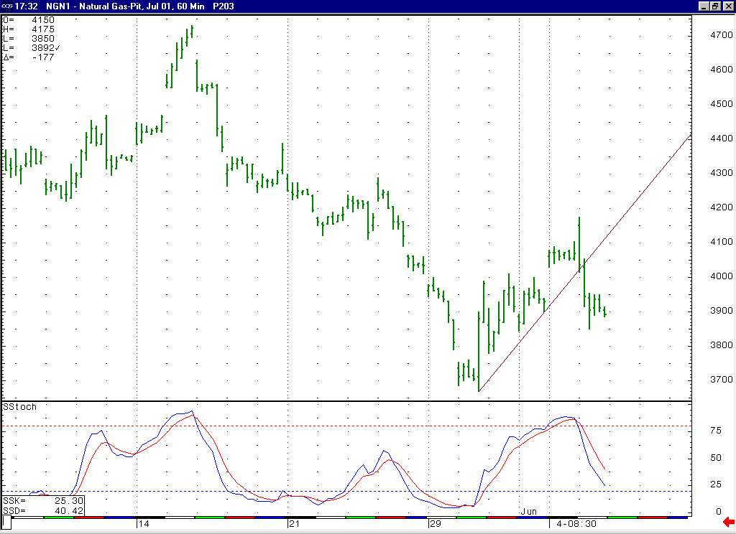
Notice the sharp downward follow through that was witnessed once the market got below this trend line yesterday.
When the market moved into a near term overbought condition here recently it reacted in a very similar manner to what occurred the last time it was overbought like this (when it put in the 4.73 high).

Technical Discussion: We continue to view the recent weakness off of the 4.73 high as occurring in a minor degree wave 5 position. With the sharp downward reversal that was witnessed yesterday, the move up to 4.175 appears to most likely have occurred as the wave 4 of this wave 5 (although if this is the case, then it would have been preferable to see this rally conclude with the 4.10 resistance more or less left intact). If this is the case, then we should see the market move back to one more new low in order to conclude this minor degree wave 5. Once this minor degree wave 5 has concluded, this should also conclude the larger degree wave 5 (which began from the late March high), which should then conclude the entire drop off of this past winters high. Even if this wave 4 scenario is not the case, then we should at minimum see the market moving somewhat lower in the near term in order to work off the near term overbought state it had moved into. We continue to believe that at some point ahead of us we will see a very sizeable short covering rally that will force the “funds” to bail out of their rather large net short position.

The information herein is believed to be reliable, however Capstone Trading Advisors Inc. does not warrant its completeness or accuracy. The opinions and estimates contained constitute our judgment and are subject to change without notice. Past performance is not indicative of future results. The information contained herein is not intended as an offer or solicitation for the purchase or sale of any financial instrument or commodities. Chart provided with permission from CQG Inc.

