Capstone Trading Advisors Inc. 830-249-7007

Tuesday June 5, 2001

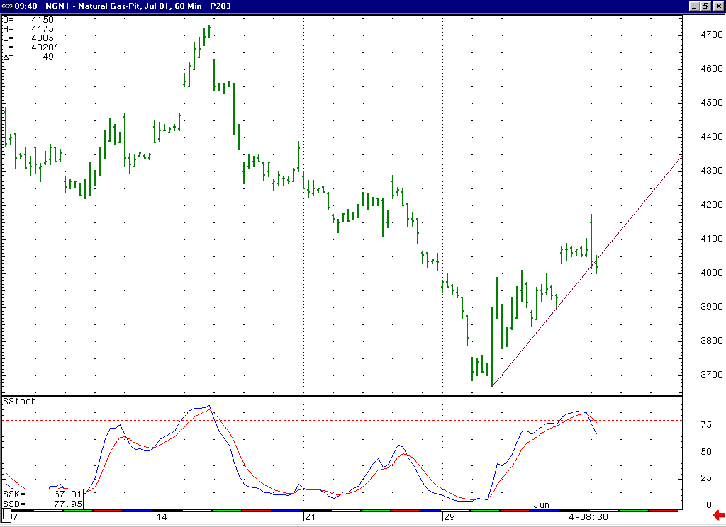
The manner in which the market was turned back ahead of the key short-term resistance in the 4.22 to 4.29 area, and then proceeded to quickly get back below the important 4.10 area, favors the idea that the market will be chopping around in the near term, likely continuing to show good two sided volatility.
The lack of upward follow through this morning along with the markets near term overbought condition should combine to see the market move down enough in the near term to at minimum relieve this near term overbought condition.

The information herein is believed to be reliable, however Capstone Trading Advisors Inc. does not warrant its completeness or accuracy. The opinions and estimates contained constitute our judgment and are subject to change without notice. Past performance is not indicative of future results. The information contained herein is not intended as an offer or solicitation for the purchase or sale of any financial instrument or commodities. Chart provided with permission from CQG Inc.

