Capstone Trading Advisors Inc. 830-249-7007

Nat Gas Summary for 6/5/01: We continue to believe that the market has a sizeable short covering rally ahead of it. To the extent that the market can get above the 4.10 area (which it tested late yesterday), then this begins to favor the idea that this anticipated short covering rally is underway off of the recent low at 3.67. If this short covering rally is going to get moving at a frenetic pace (as we believe it should), then we are going to likely need to see the “funds” begin to cover their large net short position in an aggressive manner. If the market were to get above the key short-term resistance in the 4.22 to 4.29 area in the next few sessions, then we believe that they would be forced to begin this process. If such an event were to soon occur, we could see the upward follow through that we would anticipate at that point carry the market all the way back up toward the last swing high at 4.73.

Support: 3.845 3.78 3.67 3.61 3.55 Resistance: 4.12 4.22 4.29 4.49 4.73

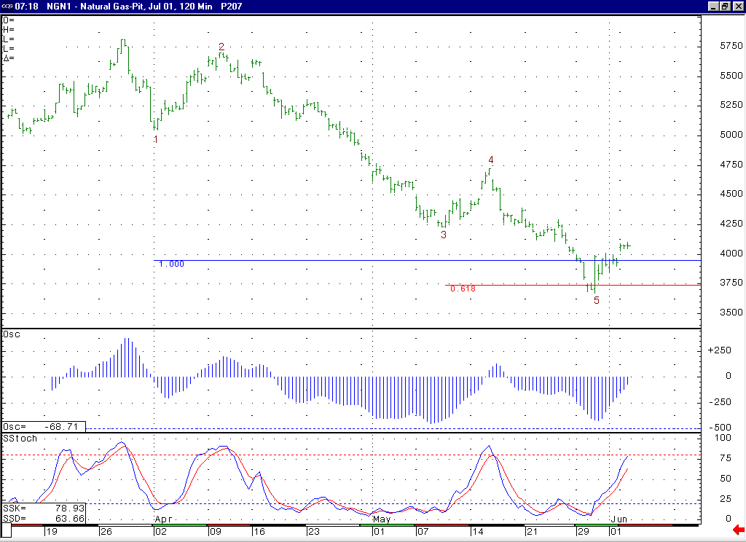
We continue to believe that this wave 5 is either completed or very late in its development. This outlook would call for the market to be moving higher in a substantial short covering rally in the coming days / weeks. However, one thing to watch in the short-term is the fact that the market is now moving into a near term overbought situation for the first time since the 4.73 high was put in place.

Technical Discussion: We continue to view the recent weakness off of the 4.73 high as occurring in a minor degree wave 5 position. To the extent that the market begins to move up off of its recent low at 3.67 in an impulsive manner, this will begin to make the case that this wave 5 has concluded. When this wave 5 has concluded the initial target for the ensuing move higher lies at the previous minor degree wave 4 high, which is located at 4.73. If the “funds” begin to aggressively cover their quite large net short position in the coming days (we believe that getting above the key short term resistance in the 4.22 to 4.29 area would most likely trigger this occurrence), then we could easily see the market being able to reach up to this target at 4.73. We expect the market to remain quite choppy and volatile in the coming days.

The information herein is believed to be reliable, however Capstone Trading Advisors Inc. does not warrant its completeness or accuracy. The opinions and estimates contained constitute our judgment and are subject to change without notice. Past performance is not indicative of future results. The information contained herein is not intended as an offer or solicitation for the purchase or sale of any financial instrument or commodities. Chart provided with permission from CQG Inc.

