Capstone Trading Advisors Inc. 830-249-7007

Nat Gas Summary for 6/4/01: We continue to believe that the market has a sizeable short covering rally ahead of it. The question now at hand is whether or not this occurrence is currently underway. The lack of upward follow through witnessed in the last couple of sessions would suggest that the market might need to see one more marginal new low prior to beginning this short covering rally in earnest. If the market were to now get back below the key short-term support at 3.78, then it will likely follow through to a new low (below 3.67) in the near term. Even if this does occur, we still feel that the current decline is quite late in its development, and that this therefore would not warrant pressing the short side of the market down at these levels.

Support: 3.845 3.78 3.67 3.61 3.55 Resistance: 4.01 4.10 4.22 4.29 4.73

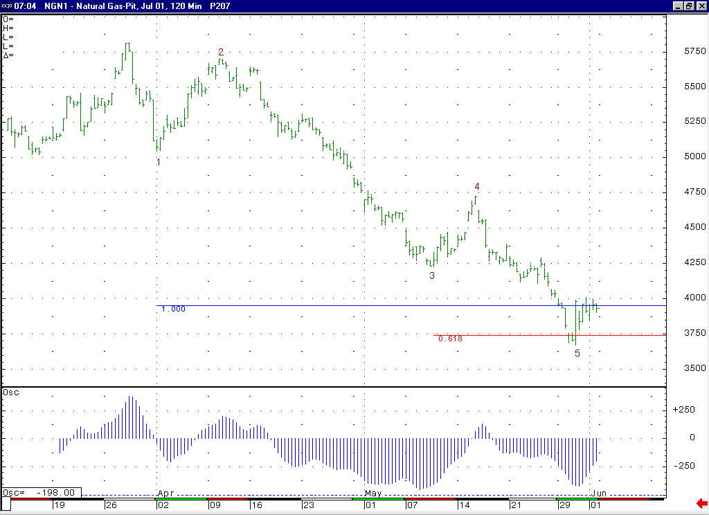
When this minor degree wave 5 concludes (if this has not already occurred), then we expect to see a sizeable short covering rally in the market (especially if we can see the “funds” begin to cover their large net short position in earnest).
The shape of this 5-35 oscillator supports our labeling here that shows the recent weakness off of the 4.73 high is occurring in a minor degree wave 5 position.

Technical Discussion: To this point the market has been able to hold the longer-term support in the 3.89 to 3.61 area as expected. We believe if the market can continue to hold in this area, then this should lead to a significant short covering rally at some point. The sharp reversal witnessed off of the 3.67 low recently gave us a chance that this anticipated short covering rally might have been underway. However, in looking at the recent incredibly volatile action off of that low it appears possible at this point that this action is occurring as the wave 4 of the minor degree wave 5 decline unfolding off of the 4.73 high. If the market were to now get below the key short term support at 3.78, then this would enhance this idea, and likely lead to near term follow through to a new low below 3.67. If this does occur then we would view this move down to new lows as most likely being the final portion of this minor degree wave 5 decline (which would also be concluding the larger degree wave 5 decline unfolding off of the late March high basis the perpetual).

The information herein is believed to be reliable, however Capstone Trading Advisors Inc. does not warrant its completeness or accuracy. The opinions and estimates contained constitute our judgment and are subject to change without notice. Past performance is not indicative of future results. The information contained herein is not intended as an offer or solicitation for the purchase or sale of any financial instrument or commodities. Chart provided with permission from CQG Inc.

