Capstone Trading Advisors Inc. 830-249-7007

Nat Gas Summary for 6/1/01: We have been expecting a sizeable short covering rally from the market. The question now at hand is whether or not this occurrence is currently underway. The lack of upward follow through witnessed above 3.99 yesterday afternoon does not support this idea. If the market were to now get back below the key short-term support at 3.78, then it will likely follow through to a new low (below 3.67) in the near term. Even if this does occur, we still feel that the current decline is quite late in its development, and that the anticipated sizeable short covering rally is still ahead of us.

Support: 3.78 3.67 3.61 3.55 Resistance: 4.01 4.09 4.22 4.29 4.73

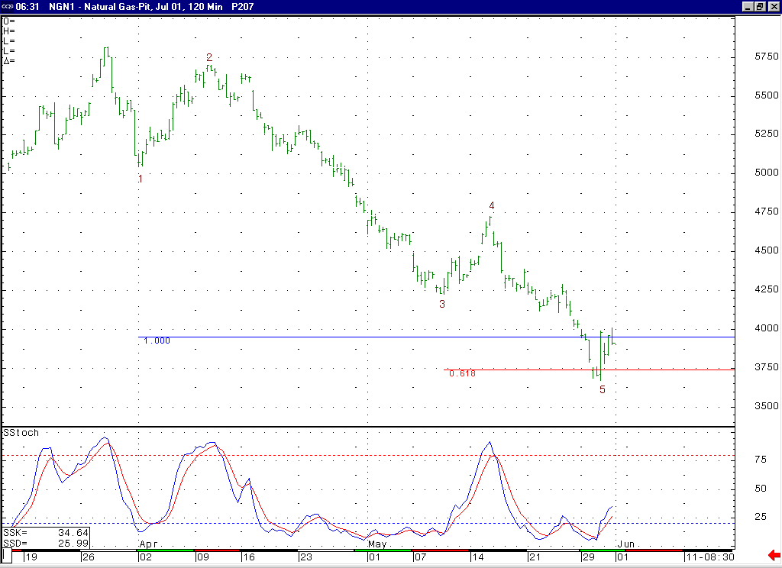
The tremendously volatile action that has unfolded off of the 3.67 low appears at this point that it may be occurring as the wave 4 of this minor degree wave 5 decline. If this is the case, then the market will need to see one more new low in order to conclude this wave 5 prior to the anticipated sizeable short covering rally occurring. This extreme two-sided volatility that has been witnessed can sometimes signal that the market is in the process of making a decision or shifting gears.

Technical Discussion: To this point the market has been able to hold the longer-term support in the 3.89 to 3.61 area as expected. We believe if the market can continue to hold in this area, then this should lead to a significant short covering rally at some point. The sharp reversal witnessed off of the 3.67 low recently gave us the chance that this anticipated short covering rally might have been underway. However, in looking at the recent incredibly volatile action off of that low it appears most likely at this point that it has occurred as the wave 4 of the minor degree wave 5 decline unfolding off of the 4.73 high. If the market were to now get below the key short term support at 3.78, then this would enhance this idea, and likely lead to near term follow through to a new low below 3.67. If this does occur then we would view this move down to new lows as most likely being the final portion of this minor degree wave 5 decline (which would also be concluding the larger degree wave 5 decline unfolding off of the late March high basis the perpetual).

The information herein is believed to be reliable, however Capstone Trading Advisors Inc. does not warrant its completeness or accuracy. The opinions and estimates contained constitute our judgment and are subject to change without notice. Past performance is not indicative of future results. The information contained herein is not intended as an offer or solicitation for the purchase or sale of any financial instrument or commodities. Chart provided with permission from CQG Inc.

