Capstone Trading Advisors Inc. 830-249-7007

Nat Gas Summary for 5/31/01: To this point the market has held the longer-term support (the lower end of which is at 3.61) as we had expected, and it appears to have begun its anticipated short covering bounce off of this support as well. We had warned that the initial reversal in the market could be quite swift and large, and it certainly appears to have started that way so far. If the market were to be able to take out the important short-term resistance in the 4.22 to 4.29 area in the next couple of sessions, then we could see this short covering rally get fairly serious (that is the point at which we believe that the “funds” would begin to cover their quite large net short position in earnest).

Support: 3.865 3.79-3.76 3.67 3.61 Resistance: 4.00 4.09 4.22 4.29 4.73

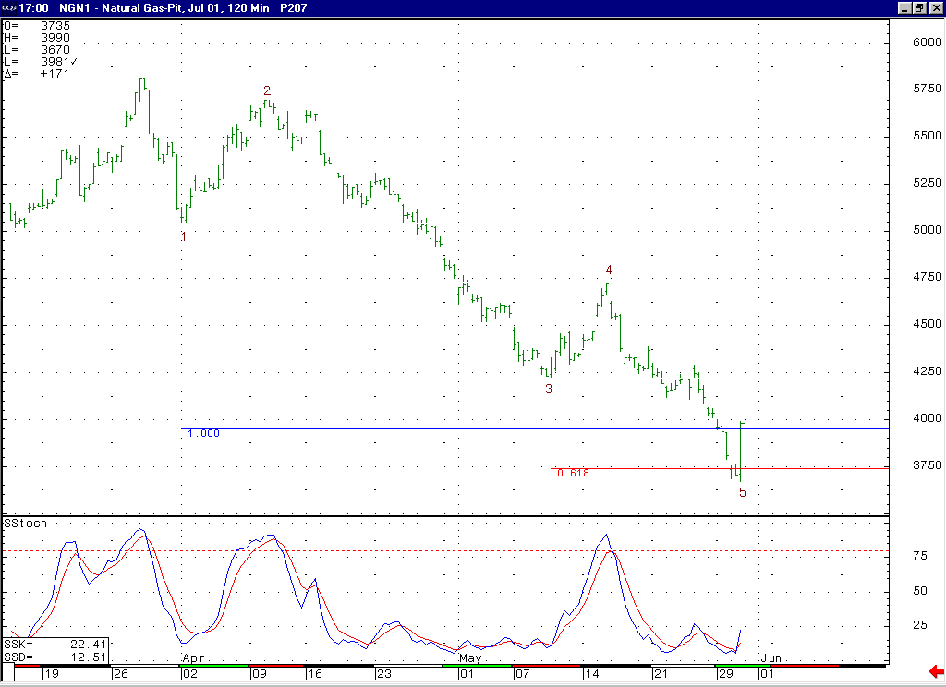
We would expect to now see a good short covering rally at minimum in order to relieve the markets near term oversold condition (which it is also very oversold on a daily and weekly basis as well).
The market reached right down to its lower primary wave 5 target here at 3.74 and then showed us the first signs of a reversal. This anticipated action would support the idea that this wave 5 has now completed at the 3.67 low.

Technical Discussion: The market reached down to (and just slightly below) its second primary minor degree wave 5 target at 3.74 yesterday, and then proceeded to show the first signs of reversal that we have seen since being in this wave 5. This action is very much in line with our expectations for the market. And this action would cause us to believe that it is now likely that this minor degree wave 5 has completed. If this is the case, then this would call for the market to be heading higher in the weeks ahead (in a good short covering rally at minimum). The target for the initial move off of this low would lie at the previous minor degree wave 4 peak, which is the 4.73 high made a couple of weeks ago. In looking at the longer-term picture (basis the perpetual chart), this minor degree wave 5 appears to have also concluded a larger degree wave 5, which if this is the case should conclude the entire decline off of this winter’s high. If this is the case, then this would call for a lengthy and choppy advance that consolidates this six and a half dollar drop.

The information herein is believed to be reliable, however Capstone Trading Advisors Inc. does not warrant its completeness or accuracy. The opinions and estimates contained constitute our judgment and are subject to change without notice. Past performance is not indicative of future results. The information contained herein is not intended as an offer or solicitation for the purchase or sale of any financial instrument or commodities. Chart provided with permission from CQG Inc.

