Capstone Trading Advisors Inc. 830-249-7007

Nat Gas Summary for 5/30/01: The June contract got down into the target area we have been discussing (3.85 to 3.66) yesterday with its expiration. For the July contract this corresponding target area lies between 3.95 and 3.74, which it also was able to reach down into yesterday. Now we will need to see if the market is able to hold in this area (along with the with the longer term support in the 3.89 to 3.61 area) as we anticipate should occur in the coming days. Even if the market were not to hold this support area in the next few sessions, we still believe that the current leg of weakness should now be in its latter stages of development, and as such we would not want to be pressing the short side too aggressively down at these levels.

Support: 3.79 3.75 3.74 3.68 3.61 Resistance: 4.11 4.22 4.29 4.425 4.73

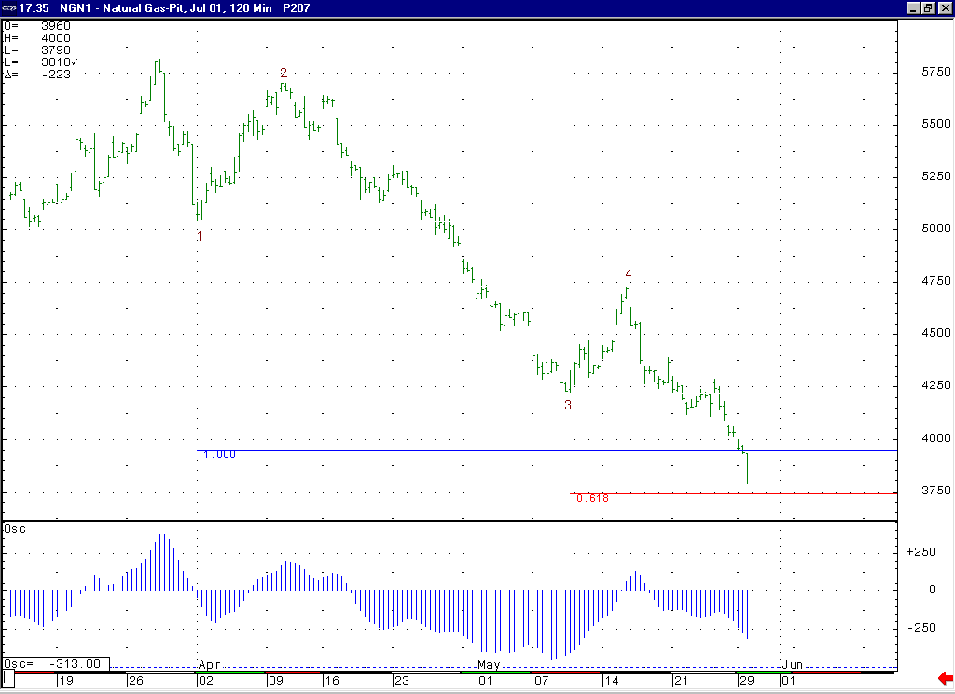
Yesterday the market was able to reach down to the primary targets for its minor degree wave 5 that we have been discussing (which are located at 3.95 and 3.74 for the July contract).
If this 5-35 oscillator is going to maintain the shape that we would expect to see during a wave 5 (for this second trough to be shallower than the first one created by the corresponding wave 3), then we are going to need to see the market turn up fairly soon.

Technical Discussion: We continue to believe that the market is currently in the process of unfolding a wave 5 of 5 decline off of the 4.73 high (basis the perpetual chart). If this wave 5 adheres to normal parameters (in other word, if it does not extend), then we should expect to see it conclude near its two primary targets located at 3.95 (the wave 5 = wave 1 extension) and 3.74 (the wave 5 = 61.8% of the total distance traveled by waves 1 thru 3), which coincides with the good longer-term support in the 3.89 to 3.61 area as well. If this decline is in fact occurring as a wave 5 of 5 as we believe, then this leg of weakness should be the final portion of the overall decline that began from this past winter’s high. The latest CFTC commitments report showed the funds getting even shorter (over 27,000 contracts net short). Given that they did not materially cover their shorts on the last significant rally to 4.73, we are concerned that when a catalyst occurs to make them cover these positions, then this can allow for a rally that is even more substantial than this previous one that carried up to 4.73.

The information herein is believed to be reliable, however Capstone Trading Advisors Inc. does not warrant its completeness or accuracy. The opinions and estimates contained constitute our judgment and are subject to change without notice. Past performance is not indicative of future results. The information contained herein is not intended as an offer or solicitation for the purchase or sale of any financial instrument or commodities. Chart provided with permission from CQG Inc.

