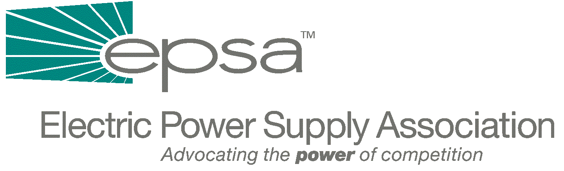

1401 New York Avenue, NW
11th Floor
Washington, DC 20005
202/628-8200
202/628-8260 fax
www.epsa.org

Memorandum
TO: | EPSA Legislative Affairs Committee  Regulatory Affairs Committee  Power Marketers Working Group
FROM: | Scott A. Weiner, Legislative Affairs Committee Chair  Jim Steffes, Regulatory Affairs Committee Chair  Bob Reilley, Power Marketers Working Group Chair  Julie Simon, Vice President of Policy  Donn J. Salvosa, Manager of Government Affairs
DATE: | September 28, 2025
RE: | - Senate Energy Hearing on FERC Order Issued on April 26th  - Wood and Brownell Nominations Forwarded to the U.S. Senate

The Senate Energy and Natural Resources Committee, chaired by Senator Frank Murkowski (R-AK), has scheduled a hearing for tomorrow, Thursday, May 3rd at 2:30 p.m. The purpose of the hearing will be to review elements of FERC’s April 26th Order on establishing mitigation and monitoring plans for California’s wholesale electricity market. FERC Chairman Curt Hebert may be the only witness, although Committee Democrats also have requested the participation of Commissioners William Massey and Linda Breathitt. Anyone wishing to hear the testimony on a live Internet broadcast can visit the Committee’s Web site at: www.senate.gov/~energy/.
The paperwork on the nominations for the two FERC vacancies has been forwarded to the Senate Energy and Natural Resources Committee. A hearing on the nominations of Pat Wood and Nora Brownell to the Commission tentatively has been scheduled for May 9th. Although Senator Barbara Boxer (D-CA) may object to the swift consideration of these nominations by the Senate (in an effort to secure a commitment to impose regional price caps), the Senate could consider these nominations in short order. It is conceivable that the new Commissioners could begin their service at FERC by the end of the month.

