Capstone Trading Advisors Inc. 830-249-7007

Nat Gas Summary for 5/29/01: We expect the market to continue lower in the near term in what we believe is likely the latter stages of its current decline (off of the late March high). While the market has yet to show any signs of a reversal, we are concerned that when this does occur there is a potential for the initial push higher in such a reversal to be quite swift and large. But until such signs present themselves, then we should see the market continue to make its way down toward its good longer-term support in the 3.89 to 3.61 area. We would be surprised to see the market getting below this support area in the days / weeks ahead (at least prior to a substantial bounce occurring). Given that we believe that this decline is now in its latter stages, we would not want to be pressing the short side too aggressively down at these levels.

Support: 3.95 3.895 3.86-3.85 3.795 3.75 Resistance: 4.02 4.12 4.23 4.31 4.395

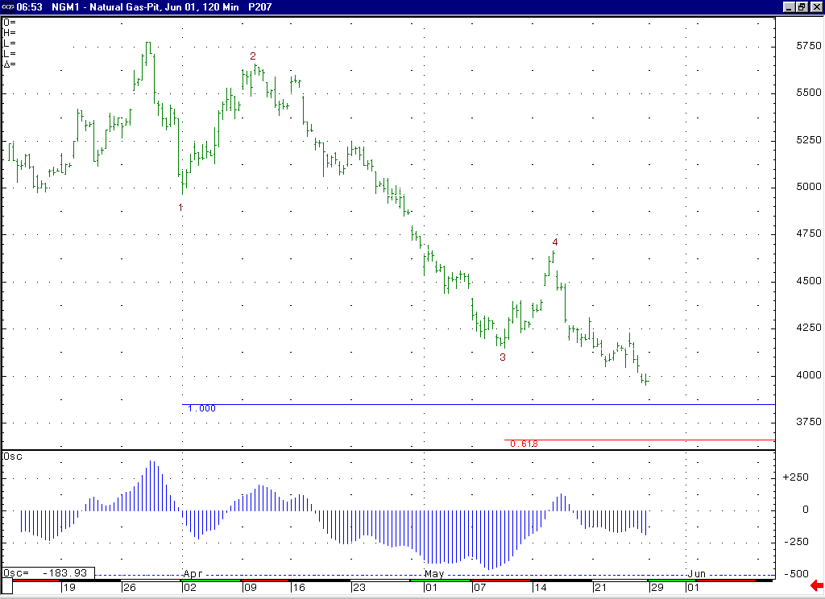
The shape of this 5-35 oscillator (making a lesser trough as the market moves into new lows) supports our idea that the current leg of weakness is occurring in a wave 5 position.
These Fibonacci extensions here at 3.85 and 3.66 are the primary targets for the conclusion of this minor degree wave 5 decline.

Technical Discussion: We continue to believe that the market is currently in the process of unfolding a wave 5 of 5 decline off of the 4.67 high. We would expect to see this decline hold / conclude in the area of its two primary targets located at 3.85 (the wave 5 = wave 1 extension) and 3.66 (the wave 5 = 61.8% of the total distance traveled by waves 1 thru 3), which coincides with the good longer-term support in the 3.89 to 3.61 area as well. If this decline is in fact occurring as a wave 5 of 5 as we believe, then this leg of weakness should be the final portion of the overall decline that began from this past winter’s high. The latest CFTC commitments report showed the funds getting even shorter (over 27,000 contracts net short). Given that they did not materially cover their shorts on the last significant rally to 4.67, we are afraid that when a catalyst occurs to make them cover these positions, then this can allow for a rally that is even more substantial than this previous one that carried up to 4.67.

The information herein is believed to be reliable, however Capstone Trading Advisors Inc. does not warrant its completeness or accuracy. The opinions and estimates contained constitute our judgment and are subject to change without notice. Past performance is not indicative of future results. The information contained herein is not intended as an offer or solicitation for the purchase or sale of any financial instrument or commodities. Chart provided with permission from CQG Inc.

