Capstone Trading Advisors Inc. 830-249-7007

Nat Gas Summary for 5/25/01: We expect the market to continue lower in the near term in what we believe is likely the latter stages of its current decline (off of the late March high). When this leg of the decline concludes, then this should likely also conclude the entire decline that has been unfolding off of the winter high. While the market has not yet shown any signs of reversal, we are concerned that when this does occur there is a potential for the initial push higher to be quite swift and quite large. But until such signs present themselves, then we should see the market continue to make its way down toward its good longer-term support in the 3.89 to 3.61 area. We would be surprised to see the market getting below this support area in the days / weeks ahead. Given that this decline now appears to be in its latter stages, we would not want to be pressing the short side too aggressively down at these levels.

Support: 4.02 3.895 3.86-3.85 3.795 3.75 Resistance: 4.145 4.23 4.31 4.425 4.67

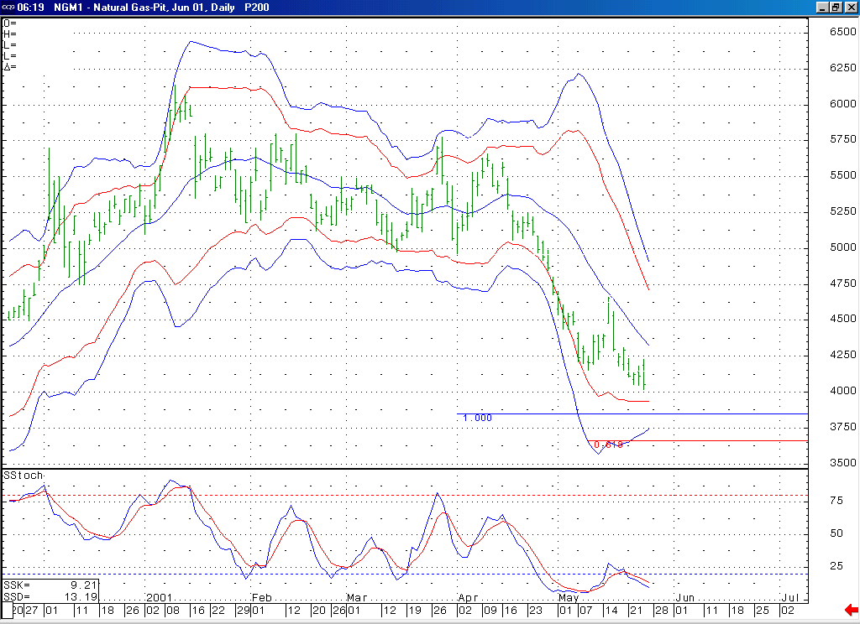
Notice that if the market were to soon turn higher, then this would create a bullish momentum divergence in this 14-bar stochastic.
With these lower Bollinger bands flattening out as they are they should act to provide the market with decent support if its moves down into this 3.90 to 3.70 area.

Technical Discussion: We continue to believe that the market is currently in the process of unfolding a wave 5 of 5 decline off of the 4.67 high. In this regard, the market has now met its minimum requirement for this decline by getting below the wave 3 of 5 low at 4.145. Below here the next primary targets lie at 3.85 (the wave 5 = wave 1 extension) and 3.66 (the wave 5 = 61.8% of the total distance traveled by waves 1 thru 3). The jury is still out as to the probabilities of the market making it down to these lower targets. Typically we will go under the assumption that a trending move will continue to the area of its primary targets until evidence appears that would suggest otherwise. However, in this case we believe that if such evidence does appear in the days ahead the potential is present for this to occur in the form of a quite sharp and substantial reversal. This potential calls for a nimble approach to the market at this time. If this decline is in fact occurring as a wave 5 of 5 as we believe, then this leg of weakness should be the final portion of the overall decline that began from this past winter’s high.

The information herein is believed to be reliable, however Capstone Trading Advisors Inc. does not warrant its completeness or accuracy. The opinions and estimates contained constitute our judgment and are subject to change without notice. Past performance is not indicative of future results. The information contained herein is not intended as an offer or solicitation for the purchase or sale of any financial instrument or commodities. Chart provided with permission from CQG Inc.

