Capstone Trading Advisors Inc. 830-249-7007

Nat Gas Summary for 5/24/01: We believe that the market is now likely in the latter stages of its current decline (off of the late March high), and that when this leg of the decline concludes, then this should likely conclude the entire decline that has been unfolding off of the winter high. While the market has not yet shown any signs of reversal, we are concerned that when this does occur there is a potential for the initial push higher to be quite swift and quite large (based on the reasons spelled out yesterday). Given this potential, we would not want to be pressing the short side aggressively down at these levels. We continue to view the 3.89 to 3.61 area as providing good longer-term support.

Support: 4.045 3.895 3.86-3.85 3.795 3.75 Resistance: 4.18 4.31 4.43 4.56 4.67

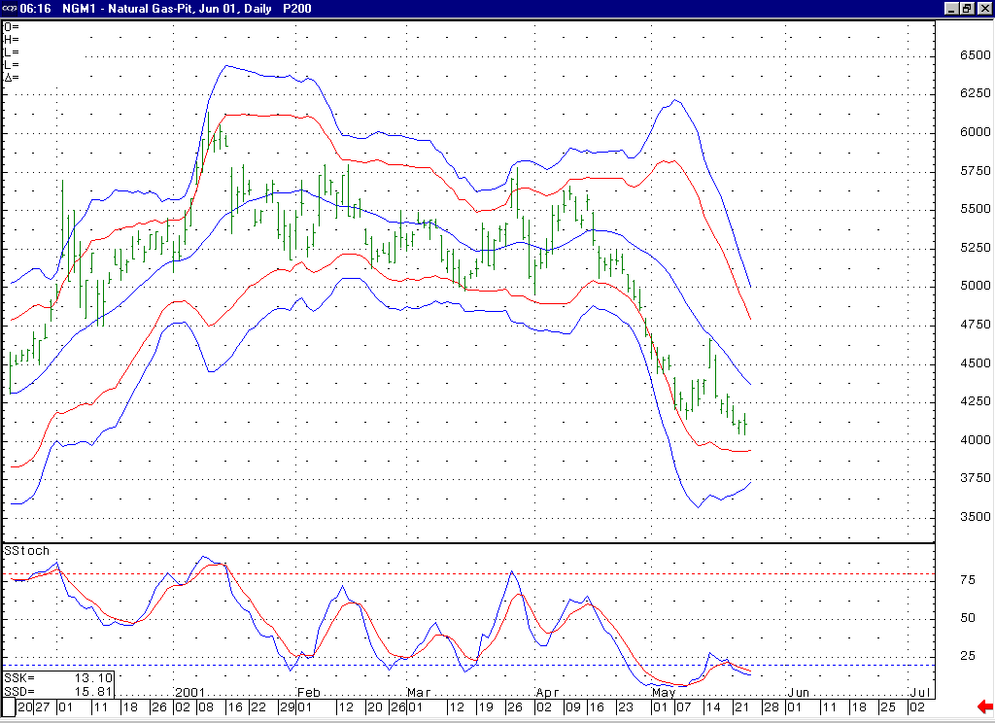
Notice that if the market were to soon turn higher, then this would create a bullish momentum divergence here in this 14-day stochastic.
Notice how these lower Bollinger bands are now flattening out, and even trying to turn higher in this 3.90 to 3.70 area. This should act to provide support in this area (corresponding with our longer-term support in this area).

Technical Discussion: We continue to believe that the market is currently in the process of unfolding a wave 5 of 5 decline off of the 4.67 high. In this regard, the market has now met its minimum requirement for this decline by getting below the wave 3 of 5 low at 4.145. Below here the next primary targets lie at 3.85 (the wave 5 = wave 1 extension) and 3.66 (the wave 5 = 61.8% of the total distance traveled by waves 1 thru 3). The jury is still out as to the probabilities of the market making it down to these lower targets. Typically we will go under the assumption that a trending move will continue to the area of its primary targets until evidence appears that would suggest otherwise. However, in this case we believe that if such evidence does appear in the days ahead the potential is present for this to occur in the form of a quite sharp and substantial reversal. This potential calls for a nimble approach to the market at this time. If this decline is in fact occurring as a wave 5 of 5 as we believe, then this leg of weakness should be the final portion of the overall decline that began from this past winter’s high.

The information herein is believed to be reliable, however Capstone Trading Advisors Inc. does not warrant its completeness or accuracy. The opinions and estimates contained constitute our judgment and are subject to change without notice. Past performance is not indicative of future results. The information contained herein is not intended as an offer or solicitation for the purchase or sale of any financial instrument or commodities. Chart provided with permission from CQG Inc.

