Capstone Trading Advisors Inc. 830-249-7007

Nat Gas Summary for 5/15/01: If the markets short covering rally was going to extend up into its target zone between 4.44 and 4.56, then we had wanted to see it get moving to the upside very soon. And in fact the market was able to accomplish this yesterday. The ideal target within this zone lies at 4.48. If we can see the market soon turn down, without materially breaching the topside of this target zone (at 4.56), then this should give it a good chance of moving back down to new lows (below 4.145) in the coming days.

Support: 4.31 4.23 4.145 3.895 3.86 Resistance: 4.44 4.48 4.56 4.725 4.85

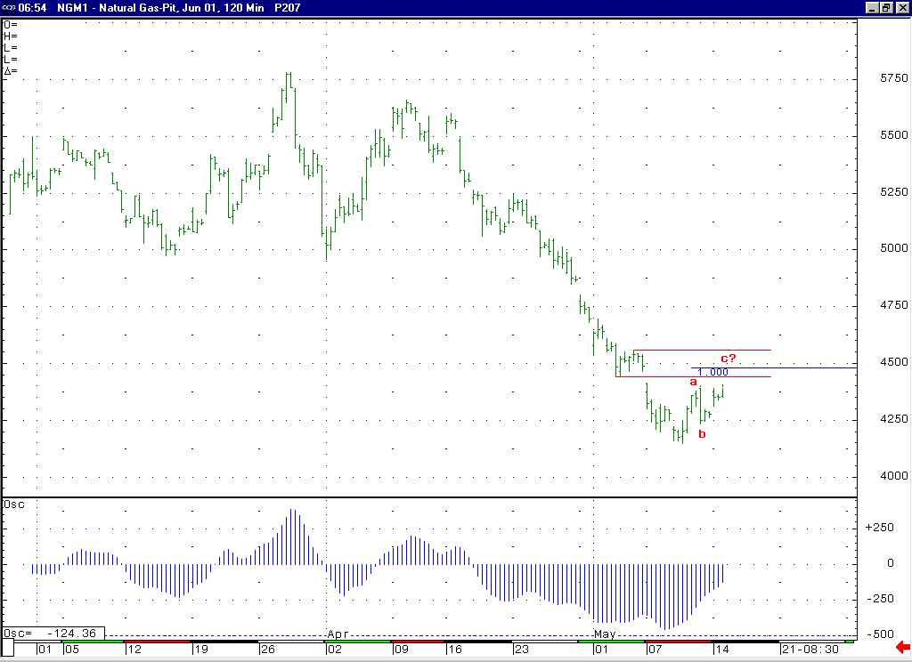
The move up off of the 4.145 low appears to us to most likely be occurring as an a-b-c (corrective shape). If this is the case, then the ideal location for its termination at this point lies at 4.48, where its C = A extension is located.
The shape of this 5-35 oscillator (moving up from its big trough, back to nearing a neutral position, or near zero value) is beginning to support the idea that this bounce is occurring in a wave 4 of 5 position.

Technical Discussion: We continue to believe that the move up off of the 4.145 low is occurring as a correction, most likely as either the wave 4 of 5, or just a minor degree correction within the ongoing wave 3 of 5. If the market can reach up toward the upper half of its 4.44 to 4.56 target zone, then this will begin to favor the wave 4 of 5 scenario. If this bounce is occurring as an a-b-c as we believe is the case, then the ideal target for the conclusion of this corrective bounce now lies at 4.48, where the C = A extension is located. We have expected corrective bounces, such as the one that we believe is now occurring, to provide us with selling opportunities in the market. In this regard, we view the current bounce as now providing us with a good risk / reward short-term trading opportunity. We would look to take on a short position in the 4.46 to 4.52 range, placing a protective stop above the 4.60 level (giving it a little room above the top of our target range at 4.56).

The information herein is believed to be reliable, however Capstone Trading Advisors Inc. does not warrant its completeness or accuracy. The opinions and estimates contained constitute our judgment and are subject to change without notice. Past performance is not indicative of future results. The information contained herein is not intended as an offer or solicitation for the purchase or sale of any financial instrument or commodities. Chart provided with permission from CQG Inc.

