Capstone Trading Advisors Inc. 830-249-7007

Nat Gas Summary for 5/14/01: The short covering rally that we had anticipated has carried the market higher, but it has to this point fallen short of our ideal target for this bounce, in the 4.44 to 4.56 area. If the market is going to have a chance to make it up to this target area, then it will need to do this very soon, and ideally without getting below Friday’s low at 4.23. In either case, once this short covering rally has concluded, we expect the market to then move back below the recent low at 4.145 at minimum, and in a fairly brisk fashion. If the market gets decent follow through in these new lows (which will likely be the case if we continue to see AGA numbers similar in size to the ones reported the past couple of weeks), then this should allow for it to move down to test its next significant support in the 3.89 to 3.61 range in the coming weeks.

Support: 4.23 4.145 4.00 3.895 3.86 Resistance: 4.40 4.44 4.56 4.725 4.85

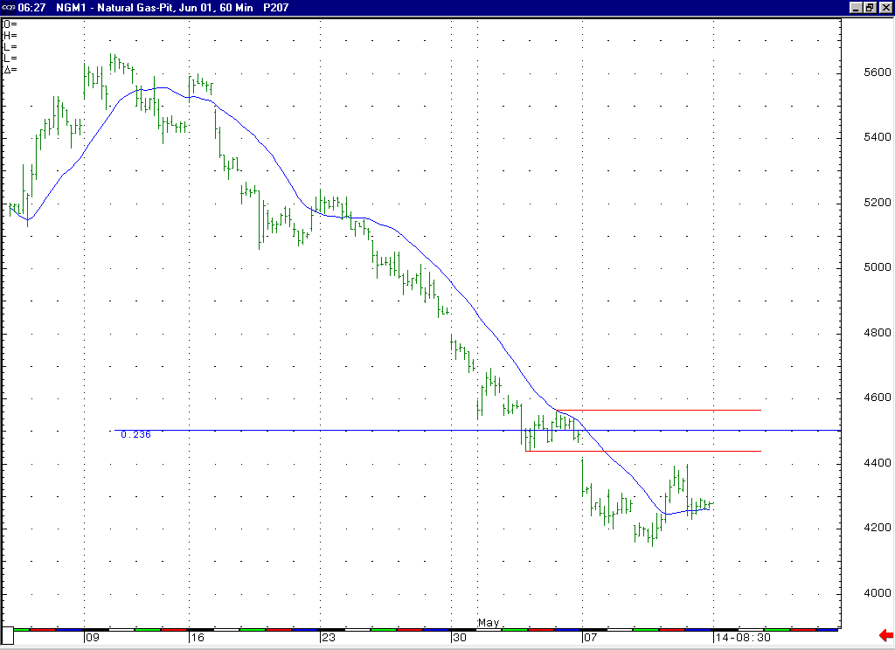
If this short covering rally off of the 4.145 low is going to continue to evolve and have a chance to reach into this target zone starting at 4.44, then it will need to begin to move higher very soon in our opinion. If this does occur, then this rally off of the 4.145 low would take on an a-b-c shape (which is ideal for a correction), and as such the ideal target for this leg higher would be locate at 4.48 (which is where the C = A extension would be located).

Technical Discussion: The question that is now at hand is whether the short covering rally off of the 4.145 low is concluded at the 4.40 level, or if it has further development to occur. If it is going to evolve further, then we believe that this will need to occur very soon. If this does occur, then this can build on the possibility that this correction is occurring as the anticipated wave 4 of 5. If instead this bounce is already complete (or if the future development is muted), then this would likely indicate that this action has occurred as a minor corrective bounce within the ongoing wave 3 of 5. The duration and size of this corrective bounce should be the determining factor between these two possibilities. In either case, it is corrective bounces such as this that we believe should provide for suitable selling opportunities in this market. In order to conclude the current leg of weakness that began from the late March high (which we believe is a wave 5), we will need to see this anticipated wave 4 corrective rally and then the corresponding minor degree wave 5 decline. If we are correct in our count, then this anticipated action should also conclude the entire rally off of the winter high.

The information herein is believed to be reliable, however Capstone Trading Advisors Inc. does not warrant its completeness or accuracy. The opinions and estimates contained constitute our judgment and are subject to change without notice. Past performance is not indicative of future results. The information contained herein is not intended as an offer or solicitation for the purchase or sale of any financial instrument or commodities. Chart provided with permission from CQG Inc.

