12” Port Lavaca Loop Line

River Crossing Leak

A gas leak was found on 12” Port Lavaca Loop Line 5/10/00 @ 9:28A.M. The gas loss from this leak was coming out of the 550 system. The 550 system has been showing a big loss for several months. A field trip to the sight indicates this leak was present for several months. There was a 60’ radius of dead vegetation around the leak inclusive of 40’ willow trees. When the trees were removed the branches were dry and brittle indicating they were dead for a long period of time.

HPL employees isolated the line on both ends and monitored the pressure drop for one hour. There was 5.52 miles of 12.750” X 0.250” pipe, 2.98 miles of 6.625” X 0.280” pipe, and 1.81 miles of 5.563” X 0.244” pipe that was inclusive of the isolated system. The monitored start pressure was 500 psig and the end pressure was 425 psig. This is a 75 psig pressure drop in one hour. The estimated gas loss for this test is 172.6 MCFH or 4,142 MCFD.

The pictures below are of the leak sight before the repairs were started. They demonstrate the area affected by the leak and some insight into how long it was present.

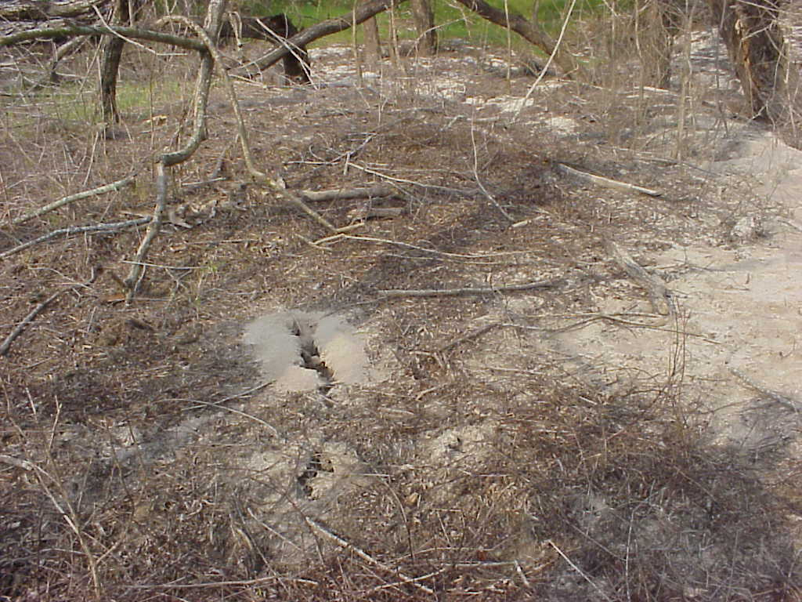

12” Port Lavaca Loop Line
River Crossing Leak

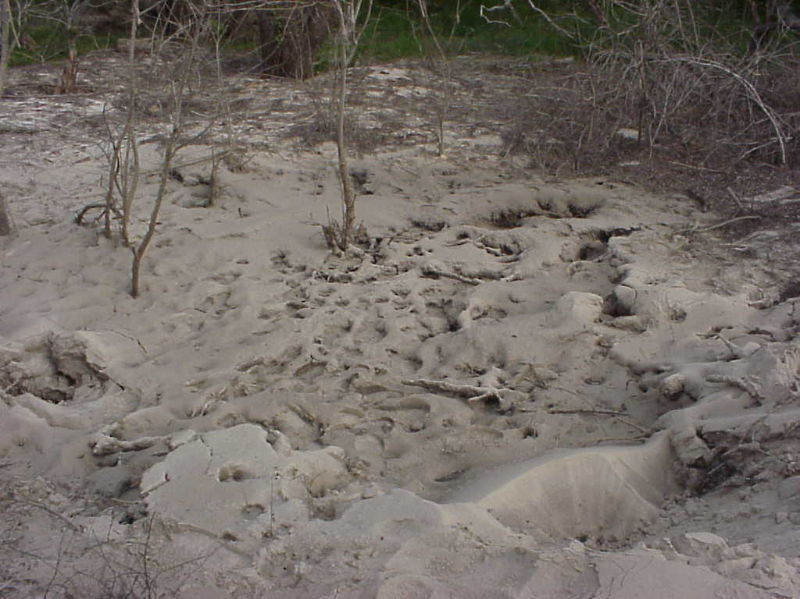

12” Port Lavaca Loop Line
River Crossing Leak

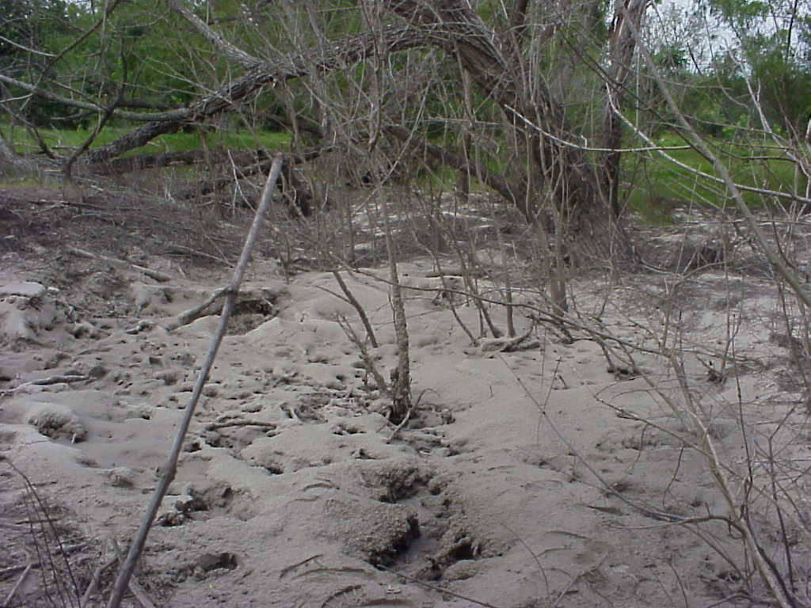

12” Port Lavaca Loop Line
River Crossing Leak
There is about a 60’ radius of dead vegetation around the leak.

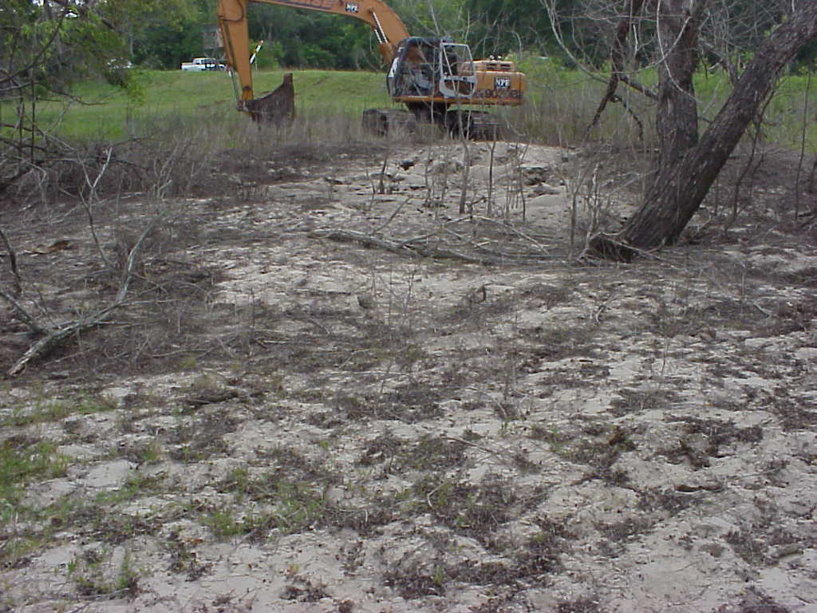

12” Port Lavaca Loop Line
River Crossing Leak
This is an overall look at the leak with the dead vegetation surrounding the leak.

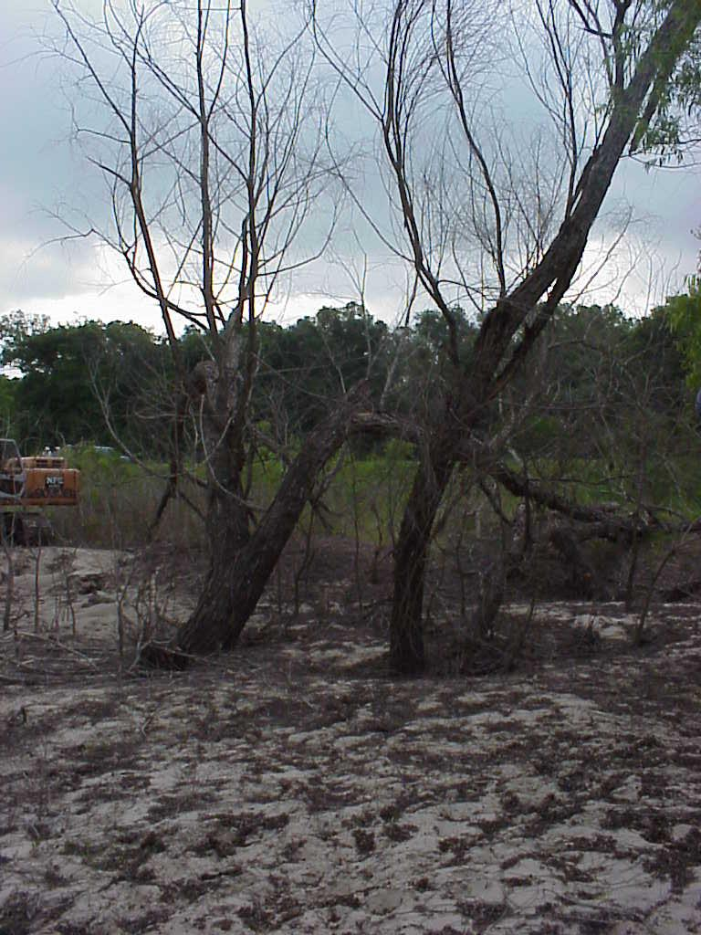

12” Port Lavaca Loop Line
River Crossing Leak
This willow tree is about 40’ tall and has been dead for a while. The branches were hard and dry indicating this leak has been present for several months.

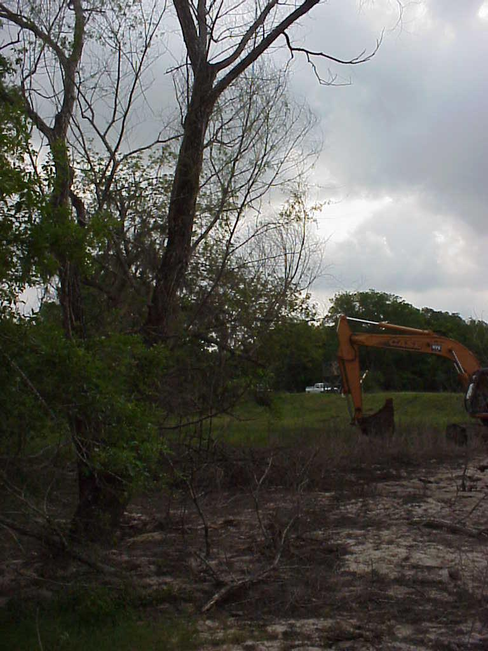

12” Port Lavaca Loop Line
River Crossing Leak
This is another dead willow tree caused by the leak.

