EnronOnline: New Challenges, New Decisions
On November 29, 1999, EnronOnline began electronic trading of U.S. and Canadian gas. (See Exhibit 1.) Almost immediately, Louise Kitchen’s concern, “Would anyone turn it on?” evaporated. Only seven weeks later—with the service expanded to include global trading in fossil fuels, electricity, plastics, paper, pollution credits and weather derivatives—EnronOnline accounted for nearly 20% of the total volume of all Enron trades. At a 2000 Annual Analyst Conference, the company announced that in less than three months since EnronOnline went live, over 450 customers around the world had used the system, over 10,000 transactions had been completed, and that EnronOnline transaction levels reached a new record with over 700 transactions, representing a notional value of $250 million. EnronOnline quickly became the world's largest web-based e-commerce site in terms of dollar volume.
The year 2000 brought record results for Enron Corp., with net income up 32% and revenues topping the $100 billion mark for the first time. For EnronOnline, 2000 marked the first year its trading efforts showed results. During the year, Enron executed 548,000 transactions online with 3,000 customers, totaling $336 billion of gross value. In addition to expanding the market reach of 1,200 wholesale commodity products (See Exhibit 2.), EnronOnline's internal features enabled very significant expansion in scale, efficiency, information and liquidity. For example, before the launch, each desk of two or three traders used to handle about 100 transactions a day, when doing their business by phone. In early-2001, a desk handled 800 to 900 transactions in gas and electricty, mostly on EnronOnline. (See Exhibit 3 for percentage of online transactions.) It was not unusual for Enron top traders to execute 1,500 trades a day. In addition, as the company reported, its transaction processing costs with EnronOnline were significantly lower than costs associated with traditional methods.
While Enron’s natural gas and power businesses were growing by leaps and bounds online, analysts predicted that that growth would slow considerably as more industry players and independent e-marketplaces were getting into the act. Competitors were popping up almost weekly. In September 2000, six energy companies created TradeSpark, hoping to become the leading global electronic trading platform, and a month later, IntercontinentalExchange, a consortium of several energy giants and investment banks based in Atlanta, launched online energy trading.
In April 2000, EnronOnline was folded under Enron Net Works, a new business incubator created to explore opportunities to extend Enron's network business model to wholesale commodities markets. The 1,500-employee unit was using its EnronOnline e-commerce platform to establish new markets in various commodities such as pulp and paper, data storage, logistics services, agricultural products and any other commodity that was potentially tradeable.
In August 2001, Louise Kitchen was appointed the CEO of Enron Net Works. With her development project now at the core of a new operating unit, Kitchen realized that she would have to respond to the top management’s expectations that Enron Net Works become a profitable part of the company. As she started receiving a number of business ideas from the front lines, some were proposing to license or sell EnronOnline software. Kitchen had to decide how to respond:
Now that we are a profit center, we do have targets to make. We are looking at how we can build new businesses, but also how we can leverage those things that we have created over the last year. Part of EnronOnline is the software. The question is: What is its value? Should we license it or should we sell it? Or perhaps we should keep it, because it’s competitive information and no one else comes close in terms of how we are managing the prices internally across this system. My role now is to make sure the people can get enough help to take those ideas forward. What you’ve got to do is make sure you don’t stem the enthusiasm, but show them the realistic probability of success. And then get them on to the next idea.

Exhibit 1 EnronOnline quotes page
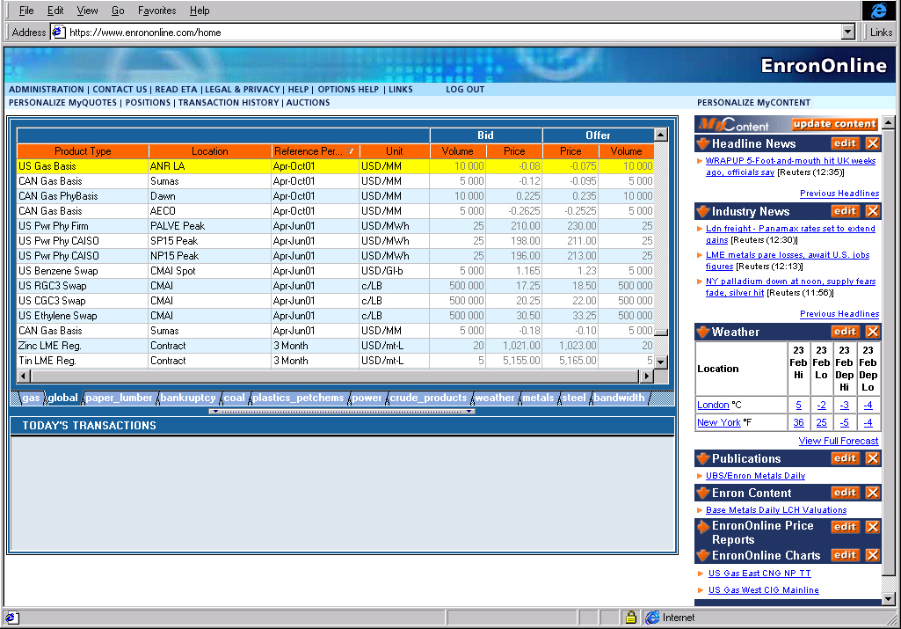

Source: Enron Corp.
Exhibit 2 EnronOnline transactions as a percentage of total transactions

Source: Enron Corp.
Exhibit 3 EnronOnline markets
1999—4Q | 2000
Natural Gas  U.S.  Canada | Natural Gas  U.K.  Belgium  Argentina | Bandwidth | Metals  U.S.  U.K.  Japan
Power  U.S.  Nordic | Power  U.K  Germany  Holland  Switzerland  Austria  Spain  Nordic Pool | Weather  U.S.  Europe  Japan  Australia | Sea freight
Coal | Coal  European  U.S. | Emissions Credits | Lumber
Pulp & Paper |  | Crude & Refined Products | Auctions  Emissions  EnBank Virtual Storage
Plastics |  | Petrochemicals | Pipeline Capacity
 |  | Liquefied Petroleum Gas | Credit Derivatives
 |  | Steel
Source: Enron Corp.

