Capstone Trading Advisors Inc. 830-249-7007

Nat Gas Summary for 2/6/02: We continue to believe that the very significant decline off of the late Dec high at 2.97 has now likely concluded, and given way to the short covering rally / consolidation that we were expecting to follow it. We expect this short covering rally / consolidation to take two to three weeks to unfold at minimum. The question at hand about this anticipated consolidation is whether it will be able to carry the market higher in any significant manner in the weeks that follow, or if it instead will be of a more sideways variety. If the market is going to maintain a good chance of chopping higher in the near term, then we would now like to see it hold the short-term support in the 2.065 to 2.03 area. In either case we will be expecting the action in this timeframe to give us a better opportunity to reestablish short positions. If the market is going to carry higher during this process, then the main hurdle that it will need to clear is the good short-term resistance in the 2.17 to 2.22 area.

Support: 2.065 2.04-2.03 1.96 1.85 Resistance: 2.13 2.17 2.21-2.22 2.29 2.38

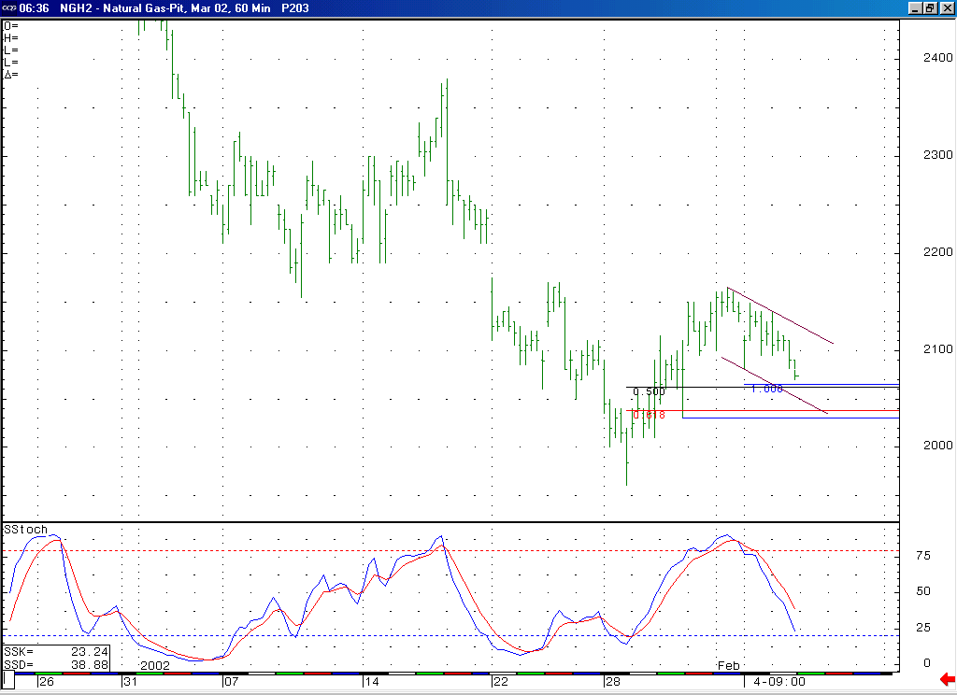
We would ideally like to see the market testing and holding the short-term support in the 2.065 to 2.03 area at the same time that the market has moved into a near term oversold condition (basis the 14-bar stochastic).
If the market is going to have a good chance of reaching higher levels within this consolidation, as we believe it should, then it would be best to see it hold this short-term support here in the 2.065 to 2.03 area in the near term.

Technical Discussion: We have been viewing the recent decline (off of the 2.38 high) as occurring in a minor degree wave 5 position. The market has met our downside objectives for this wave 5, and has followed this by beginning to chop its way higher in what we believe is another counter-trend move (or a consolidation). The recent loss in downward momentum that we have witnessed should support this belief that the recent low at 1.96 is indeed one of significance. We believe that during this consolidation period we area likely to see higher prices than what has occurred to this point (2.165 high). If this is going to be the case, then it would be best to see the market hold the short-term support in the 2.065 to 2.03 area at this time. With the market in a consolidation mode at this time, it should be expected to trade in a very choppy manner. However, we are expecting to see the volatility in the market continue to contract as we move through this Spring and Summer.

The information herein is believed to be reliable, however Capstone Trading Advisors Inc. does not warrant its completeness or accuracy. The opinions and estimates contained constitute our judgment and are subject to change without notice. Past performance is not indicative of future results. The information contained herein is not intended as an offer or solicitation for the purchase or sale of any financial instrument or commodities. Chart provided with permission from CQG Inc.

