Capstone Trading Advisors Inc. 830-249-7007

Nat Gas Summary for 2/5/02: We continue to believe that the very significant decline off of the late Dec high at 2.97 has now likely concluded, and given way to the short covering rally that we were expecting to follow it. We expect this short covering rally to take two to three weeks to unfold at minimum. The question at hand about this anticipated short covering rally is whether it will be able to carry the market higher in any significant manner in the weeks that follow (which is our preferred scenario), or if it instead will be of a more sideways variety. In either case we will be looking for this anticipated short covering rally to give us a better opportunity to reestablish short positions. If the market is going to carry higher in this timeframe, then the first hurdle that it will need to soon clear is the good short-term resistance in the 2.17 to 2.22 area. If the market can clearly take out this area in the days ahead, then it should set it sights on continuing on toward its next target in the 2.40 area in the ensuing days / weeks.

Support: 2.08 2.06 2.04-2.03 1.96 Resistance: 2.15 2.17 2.21-2.22 2.29 2.38

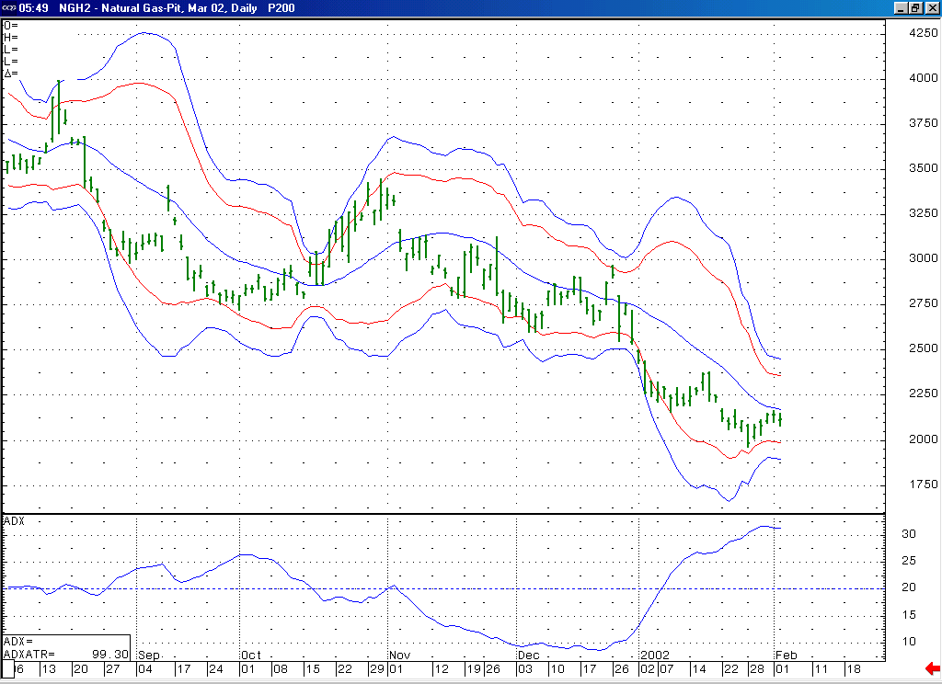
Notice how this 14-bar ADX has recently been loosing its upward slope. All that is needed now to confirm the end of this recent downtrend is to see this ADX begin to turn down and move lower in the days ahead.
If the market can soon push above its 20-day average, which it has been sitting just below recently, then this should help to confirm that a short covering rally is indeed underway, as well as open the door for the market to follow through toward its upper Bollinger bands.

Technical Discussion: We have been viewing the recent decline (off of the 2.38 high) as occurring in a minor degree wave 5 position. The market has met our downside objectives for this wave 5, and has followed this by beginning to chip away at its important near term resistance clustered in the 2.11 to 2.22 range. The recent loss in downward momentum that we have witnessed should be enough to suggest that our anticipated short covering rally is now underway off of the recent low at 1.96. This should be further confirmed however by seeing the market clear the heart of this resistance band (the 2.17 to 2.22 area) in the days that follow. If this 2.17 to 2.22 area can be cleared in the near term, then this should open the door for this short covering to continue carrying the market higher, toward its next target in the 2.40 area. With the market in a short covering mode at this time, it should be expected to trade in a very choppy manner. However, we are expecting to see the volatility in the market continue to contract as we move through this Spring and Summer.

The information herein is believed to be reliable, however Capstone Trading Advisors Inc. does not warrant its completeness or accuracy. The opinions and estimates contained constitute our judgment and are subject to change without notice. Past performance is not indicative of future results. The information contained herein is not intended as an offer or solicitation for the purchase or sale of any financial instrument or commodities. Chart provided with permission from CQG Inc.

