Capstone Trading Advisors Inc. 830-249-7007

Nat Gas Summary for 2/4/02: We continue to believe that the recent large decline in the market, off of the late Dec high at 2.97, has now likely concluded, and given way to the short covering rally that we were expecting to follow it. We expect this short covering rally to take at least two to three weeks to unfold. However, the question at hand at this time is whether this short covering rally will be able to carry the market higher in any substantial manner in the weeks that follow (which is our preferred scenario), or if it will be of a more sideways variety. In either case we will be looking for this anticipated short covering rally to give us a better opportunity to reestablish short positions. If the market is going to carry higher in this timeframe, then the first hurdle that it will need to soon clear is the good short-term resistance in the 2.17 to 2.22 area. If the market can clearly take out this area, then it should set it sights on continuing on toward its next target in the 2.40 area in the days / weeks that follow.

Support: 2.095 2.06 2.04-2.03 1.96 1.85 Resistance: 2.17 2.21-2.22 2.29 2.38

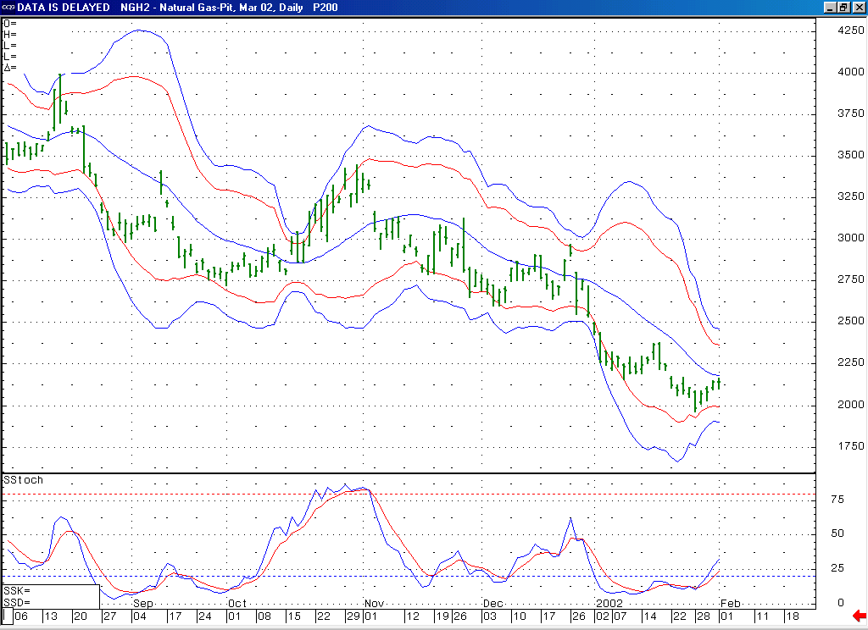
Notice the bullish momentum divergence that was created by this 14-day stochastic as it recently turned up from its oversold position.
If the market can soon push materially above its 20-day average here, then this should help to further confirm that it is in a short covering mode at this time, as well as open the door for it to follow through toward its upper Bollinger bands in the ensuing days.

Technical Discussion: We have been viewing the recent decline (off of the 2.38 high) as occurring in a minor degree wave 5 position. The market has recently been able to meet our downside objectives for this wave 5, and then follow this by moving up and beginning to chip away at its important near term resistance clustered in the 2.11 to 2.22 range. This action is enough to begin to suggest that our anticipated short covering rally is now underway. This should be further confirmed however by seeing the market clear the heart of this resistance band (the 2.17 to 2.22 area) in the days that follow. If this 2.17 to 2.22 area can be cleared in the near term, then this should open the door for this short covering to continue carrying the market higher, toward its next target in the 2.40 area. With the market in a short covering mode at this time, it should be expected to trade in a very choppy manner.

The information herein is believed to be reliable, however Capstone Trading Advisors Inc. does not warrant its completeness or accuracy. The opinions and estimates contained constitute our judgment and are subject to change without notice. Past performance is not indicative of future results. The information contained herein is not intended as an offer or solicitation for the purchase or sale of any financial instrument or commodities. Chart provided with permission from CQG Inc.

