Capstone Trading Advisors Inc. 830-249-7007

Nat Gas Summary for 2/1/02: While the market did not completely clear its important short-term resistance band (the upper end of which is located at 2.22), it did begin to chip away at it by getting well above the lower end of it in the 2.11 area. This action should be enough to increase the probabilities that the recent substantial decline has now come to a conclusion (with the alternative being that it is still in its very latter stages). If the market can now get above the 2.17 to 2.22 area this would increase these probabilities even further. We continue to look for a substantial short covering rally to follow the conclusion of this recent decline. We expect this short covering rally, if it is of a significant nature as we anticipate, to carry the market back up toward the 2.40 area at minimum (and if the “funds” were prompted to cover a good portion of their enormous short position, then it could carry substantially higher than this).

Support: 2.07 2.03-2.01 1.96 1.85 1.76 Resistance: 2.17 2.21-2.22 2.29 2.38

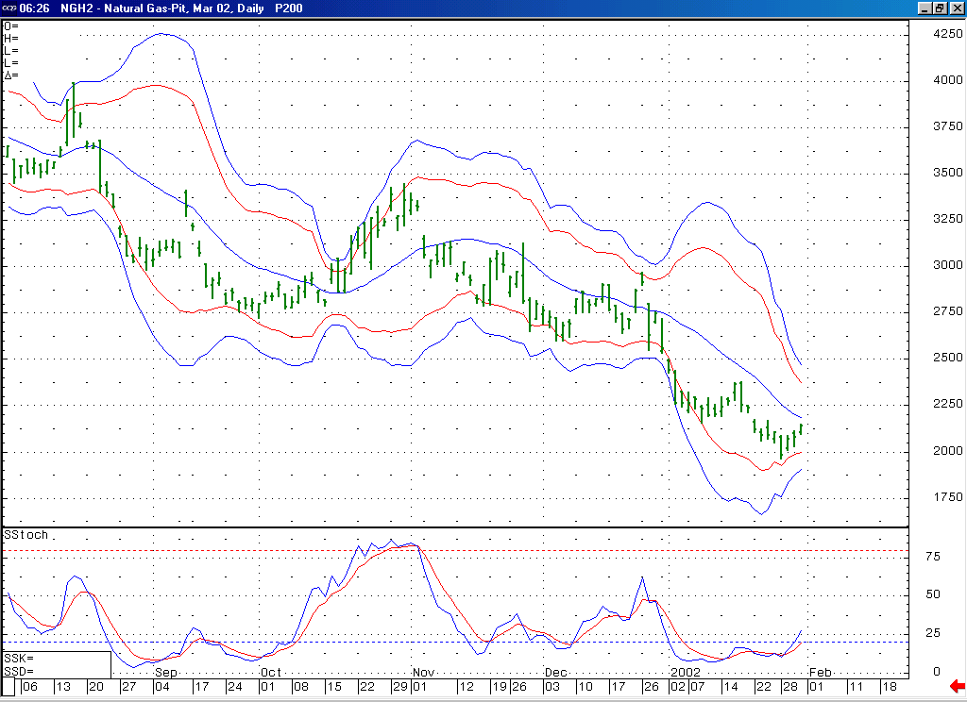
Notice that not only is this 14-day stochastic now turning up from its oversold position, but it is also creating a bullish momentum divergence as it does this.
We pointed out recently how these lower Bollinger bands have turned up, displaying a loss of downward momentum. If the market can now follow this by getting above its 20-day average here, this should go a long way toward confirming that our anticipated short covering rally is underway.

Technical Discussion: We have been viewing the recent decline (off of the 2.38 high) as occurring in a minor degree wave 5 position. The market has recently been able to meet our downside objectives for this wave 5. And it has followed this by now moving up and beginning to chip away at its important near term resistance clustered in the 2.11 to 2.22 range. This action is enough to begin to suggest that our anticipated short covering rally is now underway. This should be further confirmed however by seeing the market clear the upper end of this resistance band (at 2.22) in the days that follow. We are expecting this short covering rally to carry the market higher in a very choppy manner, toward the 2.40 area at minimum.

The information herein is believed to be reliable, however Capstone Trading Advisors Inc. does not warrant its completeness or accuracy. The opinions and estimates contained constitute our judgment and are subject to change without notice. Past performance is not indicative of future results. The information contained herein is not intended as an offer or solicitation for the purchase or sale of any financial instrument or commodities. Chart provided with permission from CQG Inc.

