$20 Bill Remembrance of 9/11
Scroll down the page and follow the directions.
1. Fold a $20 bill in half so that you see the top half of the reverse side.
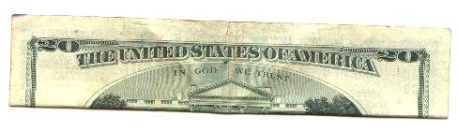
2. Fold the left half away from you as shown.
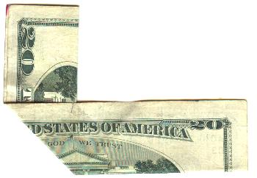
3. Fold the right half so that the burning Pentagon is revealed.
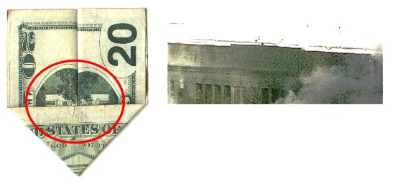
4. Flip the bill over to see the World Trade Center.
