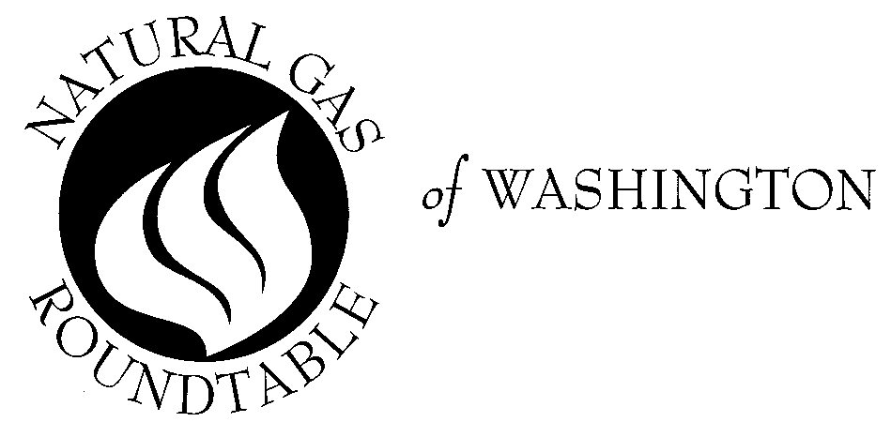

February 12, 2002

TO: Natural Gas Roundtable Members and Friends

RE: 2002 Dues and Luncheon Schedule

For 34 years the Natural Gas Roundtable has been the leading forum in Washington for natural gas policy experts from government and industry. Last year the Roundtable brought you a host of leading speakers on cutting edge national policy issues of critical importance to the natural gas industry. Our meetings featured Andrew Lundquist, Senate Energy Committee/White House Task Force; Bill Condit, House Energy and Mineral Resources Subcommittee; Stanley Horton, Enron Pipeline Group and INGAA Chairman; Jerry Jordan, IPAA Chairman; David Parker, AGA President and CEO; Rep. J.C. Watts (OK); Frank Blake, Deputy Secretary DOE; Stacey Gerard, Office of Pipeline Safety; and Mitch Daniels, Director of OMB. In addition, the open bar receptions and food at the University Club are always first rate and the camaraderie can’t be beat.

For 2002 we will continue to bring key players from the Administration, Congress, and industry to the Roundtable. For our first meeting on February 21 the guest speaker will be FERC Commissioner Nora Brownell. We hope that you will join us and be part of this great tradition by completing the attached form that includes all the dues and luncheon cost information. In the event you choose not to join, please return the attached form anyway to stay on our mailing list.

The Roundtable is again offering you a 10% discount if you choose to prepay for the 2002 luncheons. In addition, you may include your 2002 dues payment in the same check. Under the prepayment option, substitutes will be allowed, however, refunds will not be provided for any luncheons you miss. Finally, you will still need to RSVP for each luncheon.

Please mark your calendars for the luncheon dates for 2002:
Thursday, Feb. 21 Thursday, June 20 Thursday, Oct. 17
Thursday, March 21 Thursday, July 18 Thursday, Nov. 21
Thursday, April 25 No lunch August Tuesday, Dec. 17

Thursday, May 16 Thursday, Sept. 19

We look forward to seeing you at the Roundtable.

With warmest regards,

David M. Sweet
President

2002 Natural Gas Roundtable Dues and
Luncheon Payment Information

Please send in this form with your payment (you can simply attach a business card.)

Name: _________________________________________________________________

Title: ___________________________________________________________________

Organization: __________________________________________________________

Address: _______________________________________________________________

City, State and Zip Code: _______________________________________________

Phone: ________________ Fax: ____________________ E-Mail ________________

Below are payment options. Please indicate which option you choose (A, B or C).
- Prepayment of Dues and Lunch Cost:

Private Sector Members:

Dues: $ 40
Discounted Lunch Cost: 288 ($28.80 x 10 luncheons)

Total $328

Government Members:

Dues: $ 20
Discounted Lunch Cost: 207 ($20.70 x 10 luncheons)
Total $227

B. Regular Membership Dues:
Private Sector members: $40
Government members: $20

(Cost per lunch:)
Private Sector members: $32
Government members: $23

- Non-Member Status: $42/lunch (no dues check required, but please return form if you wish to remain on our mailing list.

Luncheon notices will be sent via e-mail. If you have any questions, please call Sue Swann at 202-824-7121. Please make checks payable to: Natural Gas Roundtable and return them to:
Sue Swann
American Gas Association
400 North Capitol Street, N.W., Suite 400

Washington, DC 20001

