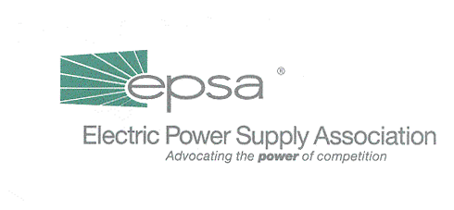
1401 New York Avenue, NW
11th Floor
Washington, DC 20005
202/628-8200
202/628-8260 fax
www.epsa.org
Memorandum
TO: | Board of Directors
FROM: | Nominating Committee
DATE: | October 22, 2001
RE: | Slate of Executive Committee Members for 2002

The Nominating Committee, consisting of current Chair B. Kent Burton, former Chair P. Chrisman Iribe, and President Lynne H. Church (as a non-voting member), nominate the following for election to the Executive Committee for 2002.

CHAIR
Stephen W. Bergstrom
President & COO
Dynegy Inc.

FIRST VICE CHAIR

Craig Mataczynski

President & CEO

NRG North America

SECOND VICE CHAIR

James Donnell

President & CEO
Duke Energy North America

SECRETARY

Clark Smith

President

El Paso Merchant Energy Group, North America

TREASURER
Frank Cassidy
President and COO
PSEG Power LLC

MEMBER-AT-LARGE
Graham Brown
Chief Operating Officer
Ontario Power Generation Inc.

