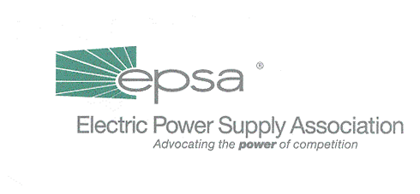
1401 New York Avenue, NW
11th Floor
Washington, DC 20005
202/628-8200
202/628-8260 fax
www.epsa.org
Memorandum
TO: | EPSA Members
FROM: | Lynne H. Church, President
DATE: | November 20, 2001
RE: | 2002 Committee & Working Group Chairs

Please join me in congratulating the following EPSA committee and working group chairs for 2002. Their tenure will take effect in January 2002.

You will note that there will no longer be a Power Marketers Working Group. That group was organized four years ago to assure that issues of interest to marketers were covered. Since that time both our membership and the nature of the issues has changed. Most of our Board and Associate level members now have marketing operations, and issues concerning market development are in the forefront. At this point, having such a subgroup within the Regulatory Affairs Committee causes a lot of confusion.

For this reason, the Executive Committee agreed with Julie Simon’s and my recommendation to disband the working group after 2001. At the same time, we recommended establishing a vice chair, since the purview of the committee is so broad.

2002 COMMITTEE & WORKING GROUP CHAIRS

Environmental Issues Committee Michael Childers, Vice President
Mirant Corp.

Industry Operations Committee Jared Long, President
Constellation Operating Services

International Issues Committee Yamin Afshar, Senior Vice President
Cogentrix Energy Inc.

Legislative Affairs Committee Scott Weiner, Senior Vice President
Sithe Energies Inc.

Accounting Working Group Kevin Polchow, Tax Director
AES Corp.

Tax Policy Working Group Shirley Myers, Vice President
TECO Energy Inc.

Political Action Committee Joseph Ronan, Jr., Vice President
Calpine Corp.

Public Affairs Committee Mark Palmer, Vice President
Enron Corp.

Regulatory Affairs Committee Chair—Robert Reilly, Vice President Shell Trading
Vice Chair—Tim Thuston, Director
Williams Energy Marketing and Trading

Natural Gas Working Group John Orr, Director
Reliant Energy

NERC Working Group Michael Gildea, Manager
Duke Energy North America

Renewables Committee Andrew Chau, Regulatory Counsel & Director
Tractebel North America

State Issues Committee Douglas McFarlan, Regional Vice President
Midwest Generation (Edison Mission Energy)

