2001 Enron Law Conference Update

The Westin Riverwalk
San Antonio, Texas
May 2-4, 2001



Attendance at all functions is reserved for attorneys, legal assistants & corporate secretary staff only. Please meet your friends and families after the events have concluded each day.

Transportation to San Antonio
Please make your own travel arrangements via air or automobile. Check our website for travel maps to get to the Westin Riverwalk.

Arrival in San Antonio
There are several options for travel to the hotel.
Airport Shuttles are located in the baggage area of the San Antonio Airport. A one-way hotel transfer is $15.
Taxis are available outside of baggage claim for a one-way fare of $21.

Hotel Registration
Upon arrival at the Westin Riverwalk, register at the front desk for your room. Your room and all incidentals are to be charged to your personal credit card. Room charges will be reimbursed on your expense account. Any incidentals are your responsibility. If you have any special requests, please contact us immediately if you have not done so already.

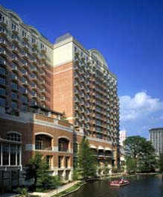

Check-out is 12 noon.

If you turned in a registration form, you are confirmed for the duration of the conference unless otherwise specified. There is no need to confirm your reservation with the hotel.

If you need to cancel a portion of your stay, please email Sara Davidson. Also, email to Sara any cancellations or additions for other activities (ie: conference, banquet, recreation).

Hotel Parking
Valet parking is available for $22 per day and self-parking is $12 per day.

Seminar Registration
Registration for the Law Conference will be held Wednesday, May 2nd from 4:00pm until 7:00pm in the foyer outside the Navarro Ballroom located on the 2nd Level of the Westin. You can pick up your registration materials including nametags, schedule of events and information about San Antonio.

Registration will reopen on Thursday and Friday at 7:15am in the Ballroom foyer.

KICKOFF RECEPTION
Wednesday we will host a casual cocktail reception outside of the Navarro Ballroom from 4:00pm until 7:00pm. While you pick up your registration materials, you can relax, discuss dinner plans and meet other Enroners with whom you can enjoy your evening. This evening is “on your own” to enjoy the San Antonio Riverwalk and all it has to offer!

CONFERENCE
The Conference begins promptly at 8:00am Thursday and ends at 11:30am when the extracurricular activities begin. On Friday, the conference begins at 8:00am and concludes at 12:30pm. Attire is casual. Please be comfortable. The ballroom may be cold throughout the morning. Jackets and sweaters may be needed.

There will be a telephone outside the Ballroom to receive messages from your offices.
Conference Phone:
(210) 444-6212
This number will only be effective during the conference hours of 8:00am – 12 noon Thursday and Friday.

To receive calls and faxes throughout the day and evening hours, use the general telephone and fax number for the Westin Riverwalk.

Phone: (210) 224-6500

Fax: (210) 444-6000

Michelle Cash’s CLE Committee has worked hard to bring you an interesting list of speakers and topics relevant to Enron and the world today. We’ve applied for 7.5 hours of CLE credit, including 2.5 hours of ethics. You will receive forms at the end of the conference to fill out to receive your credits.

RECREATIONAL ACTIVITIES
We have some great activities planned for Thursday afternoon. Meet in the Westin Riverwalk Lobby on the 1st floor next to the front desk. Buses and vans will leave from that area.

If you are participating in an activity, please look through the attachments to this document. Lists of participants, transportation, departure times, and attire will be included in each attachment.

If you need to cancel your activity this week, it is imperative that you let us know immediately. We are sold out of many of these great events and we have a waiting list! Please email Sara with any changes.

AWARDS DINNER
Our Texas hospitality will shine through as you join us for the famous awards dinner. The Institute of Texan Cultures

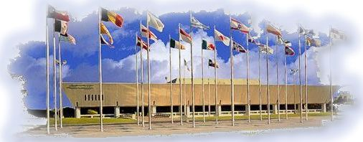

will play host to our group as we meander through the Institute and learn about our diverse cultures. Food and beverage will reflect many of the cultures. Please dress festively, in cultural attire or dressy casual. Buses will meet in front of the Westin and shuttle to the ITC beginning at 7:15pm. Upon conclusion of dinner, the real festivities begin as our Masters of Ceremony Dan Lyons, Travis McCullough and Michelle Blaine take the stage to announce the results of the day’s activities.

We look forward to a fun and entertaining conference.

Please let us know if there is anything that we have overlooked.

Fran & Sara

fberg@swbell.net
sara.davidson@enron.com

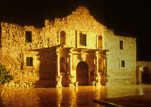

See you in
San Antonio!

