Forecasting Challenges in
U.S. and Canada Electricity Markets
2001 Electric Market Forecasting Conference
Skamania Lodge, Washington (Near Portland, Oregon)

RESCHEDULED FOR: November 12-13, 2001

The conference venue is the beautiful Skamania Lodge in the scenic Columbia River Gorge 45 minutes East of Portland International Airport, Portland, Oregon. A mind expanding setting for an executive-and professional level exchange of information and strategies concerning North American energy markets.

The Conference Agenda

Monday, November 12th Electric Market Forum (All Day)

Strategies in Volatile Energy Markets: Western U.S. Markets
Vince Kaminski, Vice President
ENRON

Innovative and Competitive Financing Strategies
Larry Kellerman, Senior Managing Director
El Paso Merchant Energy

Western Canadian Markets
Paul Blaha, Manager, Power Marketing
ATCO

Luncheon Presentation – The Historic Columbia River Gorge
Charlie Grist, Energy Policy Analyst
Oregon Department of Energy

Gas and Oil Hedging and Electric Markets
William Foley, Director, Global Commodities
Deutsche Bank (New York)

Midwestern U.S. Markets
Rosemary Smalls-Tilford, Senior Regulatory Strategist
DTE Energy

Artifice or Reality: Pricing In the Eastern Interconnection
Robert McCullough, Managing Partner
McCullough Research

Conference Kick-off Event starting at 6:00 p.m.

An Evening at the Columbia Gorge Interpretive Center
Complimentary Dinner for Attendees and Spouses

We are hosting an evening for conference attendees and their guest at the Columbia Gorge Interpretive Center. Please join us for an evening of dinner, music and private viewing of an exceptional museum in the heart of the Columbia River Gorge.

Tuesday, November 13th Applied Market Forecasting – (Morning Session)

AURORA- Release 6.0
New Feature and Database Design
Warren Winter, President
EPIS, Inc.

Modeling New Resource Development
Jim Letzelter, President
GenerSys

Data Sources for Modeling
Sara Bishop, Market Analyst
Williams Energy Marketing & Trade

Electric Market Modeling
Chris Mitchell, Senior Research Analyst
Southern California Edison

AURORA Workshop (Afternoon Session)
Energy Market Modeling, Advanced and Introductory
Principals, EPIS, Inc.

We are offering advanced and introductory sessions on energy market modeling. The advanced session will cover Risk Modeling, Portfolio Analysis, and Automation using VB scripts.

Accommodations
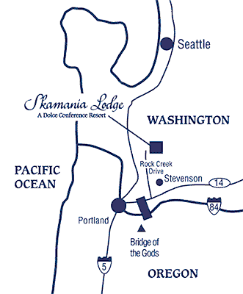
Make your own reservations at Skamania Lodge or the Columbia River Inn in Cascade Locks, OREGON, next to the Bridge of the Gods.

Skamania Lodge. To reserve a room, call 1-800-221-7117. Mention “EPIS” to get the block room rate.

Best Western Columbia River Inn at Cascade Locks, OREGON. This Inn is just five minutes away--across the Bridge of the Gods on the Oregon side of the Columbia River. To reserve a room, call direct 1-800-595-7108. Mention “EPIS ” to get block room rate.

For suggestions on other accommodations, please call EPIS at (503) 722-2023 x201.

