Capstone Trading Advisors Inc. 830-249-7007

Nat Gas Summary for 1/31/02: With the market having recently met our downside objectives, we believe that this decline should now be very near completing, if not already complete. If the market is going to have a chance to probe a little bit lower in the next couple of sessions, then we will need to see it remaining below the short term resistance in the 2.11 area. If such a probe lower were to occur, we would not expect to see much more than new lows (below 1.96). If the market is going to indicate that its anticipated bottom has already occurred, then we will need to see it getting above the very important short-term resistance clustered in the 2.11 to 2.22 area. In either case, once this decline has in fact concluded, we are then expecting the market to unfold a short covering rally. We expect this short covering rally, if it is of a significant nature as we anticipate, to carry the market back up toward the 2.40 area at minimum (and if the “funds” were prompted to cover a good portion of their enormous short position, then it could carry substantially higher than this).

Support: 2.01 1.96 1.85 1.76 1.67 Resistance: 2.11 2.155 2.17 2.21-2.22

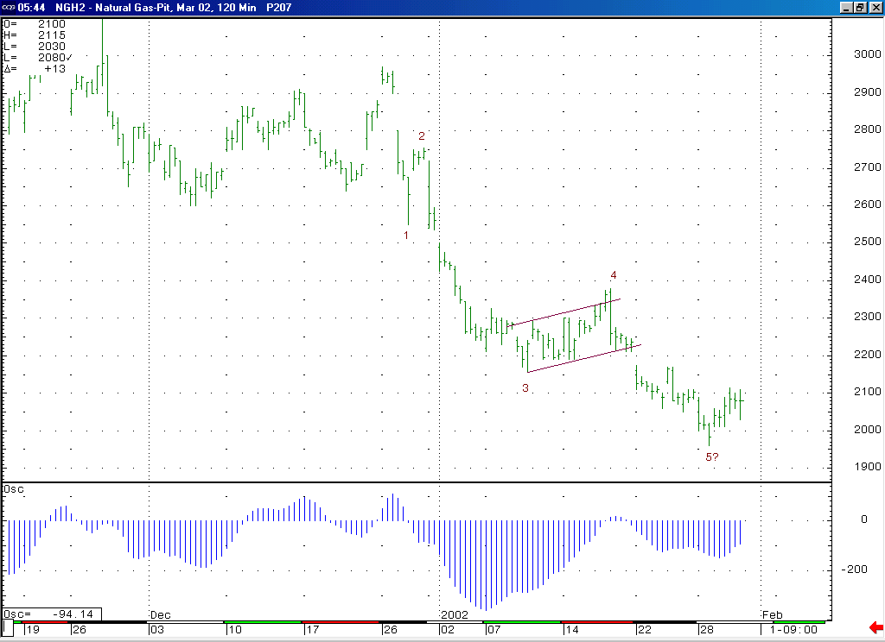
Notice how the current trough on this 5-35 oscillator has now turned back up, indicating a loss of downward momentum in the market. This likely indicates that either this wave 5 has completed, or that it needs only one more marginal push down in order to complete.
We continue to view this decline as occurring in a minor degree wave 5 position. As such, when it has completed (which should be soon, if it has not already occurred) it should be followed by a rather substantial short covering rally.

Technical Discussion: We have been viewing the current decline (off of the 2.38 high) as occurring in a minor degree wave 5 position. The market has now met our downside objectives for this wave 5. As such we believe that this wave 5 should now be in its very latter stages (if not already complete). The market currently has a great deal of resistance clustered above it, in the 2.11 to 2.22 range. If the market can break through this resistance band (especially the 2.17 level) in the days that follow, then this would be a very good indication that this wave 5 has concluded, and the significant short covering rally that is expect to follow it is underway. If this short covering rally were to begin from near current levels, then we would expect it to target the 2.40 area at minimum. If on the other hand the market can be capped by the lower end of this resistance band (2.11 area) in the near term, then this can allow it to likely push down and retest (and possibly marginally exceed) its previous low at 1.96.

The information herein is believed to be reliable, however Capstone Trading Advisors Inc. does not warrant its completeness or accuracy. The opinions and estimates contained constitute our judgment and are subject to change without notice. Past performance is not indicative of future results. The information contained herein is not intended as an offer or solicitation for the purchase or sale of any financial instrument or commodities. Chart provided with permission from CQG Inc.

