Capstone Trading Advisors Inc. 830-249-7007

Nat Gas Summary for 1/30/02: The market has had a good move lower over the preceding month. However, with it having now met our downside objectives, we believe that this decline should now likely be very late in it development. As such we would now want to be out of the remainder of short positions. While the March contract may try to probe down a little more in the next couple of days, toward the levels seen in the last couple of days of the Feb contract, numerous technical factors now suggest that a short covering rally should be forthcoming. We would expect such a short covering rally, if it is of a significant nature as we anticipate, to carry the market back up toward the 2.40 area at minimum (and if the “funds” were prompted to cover a good portion of their enormous short position, then it could carry substantially higher than this).

Support: 2.01 1.96 1.85 1.76 1.67 Resistance: 2.11 2.155 2.17 2.21-2.22

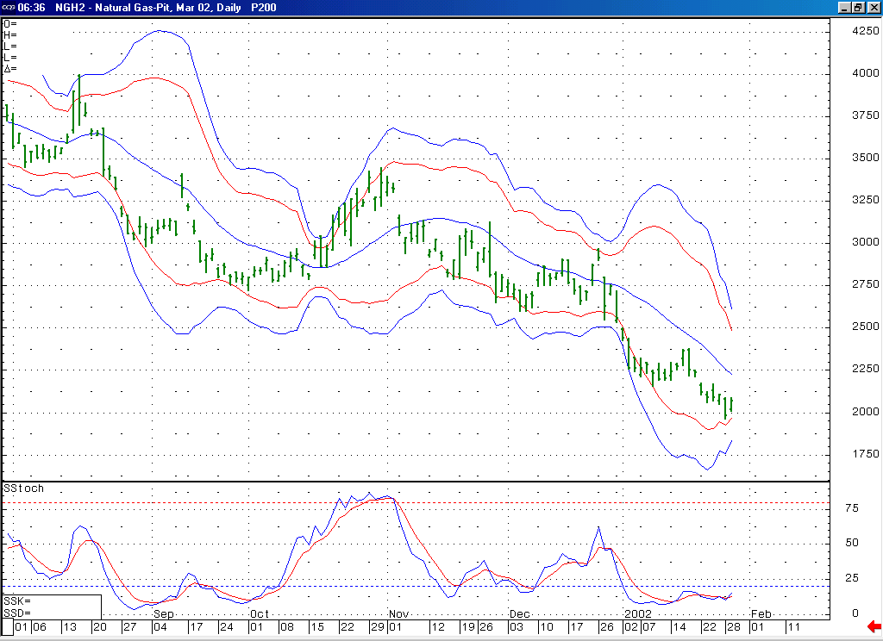
The market is not only oversold here on a daily basis (as indicated by this 14-day stochastic), but if the market soon turns up from near here you can see here how it will create a bullish momentum divergence as well.
Notice how these lower Bollinger bands are now turning up, indicating a loss of downward momentum. If the market were to soon get above this 20-day average, then this would likely indicate that the anticipated short covering rally is underway.

Technical Discussion: We have been viewing the current decline (off of the 2.38 high) as occurring in a minor degree wave 5 position. The market has now met our downside objectives for this wave 5. As such we believe that this wave 5 should now be in its very latter stages. The market currently has a great deal of resistance clustered above it, beginning at 2.11 and carrying up to 2.22. If the market were to be able to break through this resistance band (especially the 2.17 level) in the days that follow, then this would be a very good indication that this wave 5 has concluded, and the significant short covering rally that is expect to follow it is underway. If this short covering rally were to soon begin from near current levels, then we would expect it to target the 2.40 area at minimum. If on the other hand the market can be capped by the lower end of this resistance band (2.11 area) in the near term, then this can allow it to likely push down to one more new low (below 1.96) in the next couple of sessions (if this did occur I would not expect such a move lower to carry any further than the 1.85 low made by the Feb contract).

The information herein is believed to be reliable, however Capstone Trading Advisors Inc. does not warrant its completeness or accuracy. The opinions and estimates contained constitute our judgment and are subject to change without notice. Past performance is not indicative of future results. The information contained herein is not intended as an offer or solicitation for the purchase or sale of any financial instrument or commodities. Chart provided with permission from CQG Inc.

