Capstone Trading Advisors Inc. 830-249-7007

Nat Gas Summary for 1/29/02: Yesterdays action was just the type of wash out below the 2.00 area that we have been discussing of late. We continue to view this type of action as having the potential of moving all the way down toward the longer-term target in the 1.76 area. However, now that this wash out is underway, this should now place the current decline very late in its development. We would now want to be out of 75% of short positions, and cover the remainder by the end of today’s session. We expect the current decline to be followed by a rather significant short covering rally in the ensuing weeks.

Support: 1.86 1.76 1.67 1.625 Resistance: 1.955 2.04 2.08 2.15 2.17-2.21

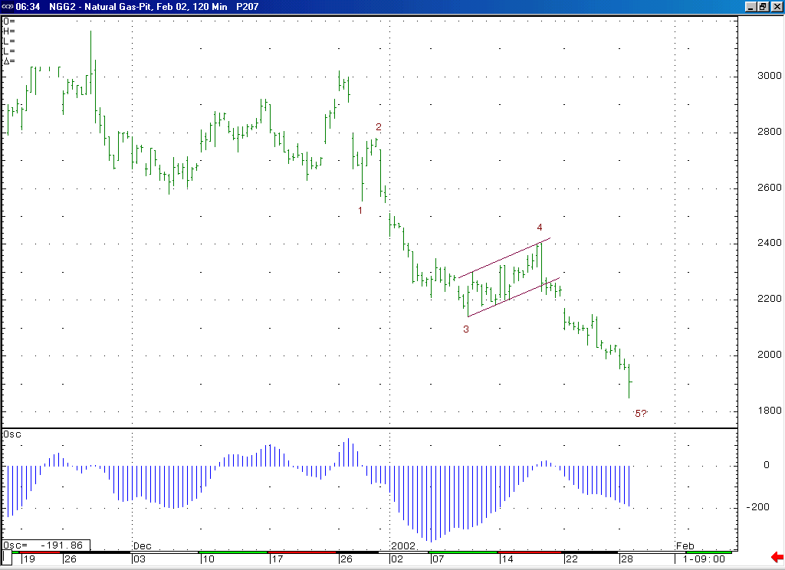
The market does in fact now appear to be getting the wash out heading in the expiration of the Feb contract that we have been discussing. This substantial move lower should now give us just the opportunity that we were looking for to cover short positions.
The market was in fact able to continue lower yesterday in a direct manner, which was necessary in order for it to avoid loosing its downward momentum. We will continue to watch the current trough on this 5-35 oscillator (which should conclude above the previous trough, thereby creating a momentum divergence) for signs of waning momentum, which should signal the conclusion of this wave 5 decline.

Technical Discussion: We continue to view the current decline (off of the 2.405 high) as occurring in a minor degree wave 5 position. The market moved beyond our 2.00 target area yesterday in the “wash out” fashion that we had been discussing, which opens the door down to the area of the longer-term target in the 1.76 area (which the market neared yesterday). If this decline is in fact occurring in a wave 5 position as we believe, then it should be followed by a more significant short covering rally once it has concluded (the fact that the “funds” area carrying an extraordinarily large net short position at last report makes for the very real potential of a very substantial short covering rally in the days / weeks ahead). We believe that the fact that the market is currently washing out below the 2.00 area in the manner that we have discussed enhances the prospects for such a significant short covering rally after this decline has concluded. If such a short covering rally were to begin relatively soon, our minimum expectations for such a move higher would lie in the 2.40 area (basis the March).

The information herein is believed to be reliable, however Capstone Trading Advisors Inc. does not warrant its completeness or accuracy. The opinions and estimates contained constitute our judgment and are subject to change without notice. Past performance is not indicative of future results. The information contained herein is not intended as an offer or solicitation for the purchase or sale of any financial instrument or commodities. Chart provided with permission from CQG Inc.

