Capstone Trading Advisors Inc. 830-249-7007

Nat Gas Summary for 1/28/02: Now that the market has reached our anticipated target in the 2.00 area we would want to be out of a good portion (30% to 50%) of short positions. The question at hand now is whether or not the market will be able to get substantially below this 2.00 target during the last couple of trading days of the Feb contract, as we have discussed. If such an occurrence takes place, then we see the potential for the market to move all the way down toward our longer-term target in the 1.76 area. But whether such a washout occurs or not, we strongly believe that we are now in the window that should provide us with a good opportunity to cover short positions. In this regard, we will want to be out of 60% to 75% of short positions by the end of today, and out of the balance of all short positions by the close tomorrow (unless the market gets above 2.15 first, at which point we would stop out of all remaining short positions).

Support: 1.99 1.94 1.86 1.76 Resistance: 2.07 2.15 2.17-2.21 2.25 2.405

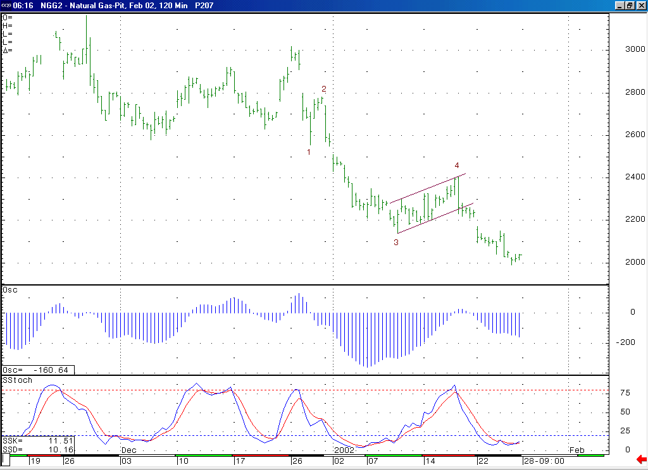
Once this decline (minor degree wave 5) has concluded, then we should see the market move back higher in a rather significant short covering rally (the initial target for such a move will lie near the minor degree wave 4 high (2.405 in the Feb, 2.38 basis the March).
The shape of this 5-35 oscillator continues to suggest that the current decline is occurring in a minor degree wave 5 position. This oscillator will bear watching, as when it begins to loose its downward momentum, this can give us an early indication that the conclusion of this wave 5 is imminent.

Technical Discussion: We continue to view the current decline (off of the 2.405 high) as most likely occurring in a minor degree wave 5 position. The market has now met our ideal target for this wave 5, which is located in the 2.00 area. However, we do continue to see a possibility for the market moving substantially below this 2.00 area as it heads into the expiration of the Feb contract, possibly even all the way back down to retest the 1.76 low made as the October contract was expiring. If this decline is in fact occurring in a wave 5 position, then it should be followed by a more significant short covering rally once it has concluded (the fact that the “funds” have again added significantly to their already extraordinarily large net short position makes for the very real potential of a very substantial short covering rally in the days / weeks ahead). We believe that if the market can get well below the 2.00 area on its current leg of weakness, then this would enhance the prospects for such a large short covering rally after this decline has concluded.

The information herein is believed to be reliable, however Capstone Trading Advisors Inc. does not warrant its completeness or accuracy. The opinions and estimates contained constitute our judgment and are subject to change without notice. Past performance is not indicative of future results. The information contained herein is not intended as an offer or solicitation for the purchase or sale of any financial instrument or commodities. Chart provided with permission from CQG Inc.

