Capstone Trading Advisors Inc. 830-249-7007

Nat Gas Summary for 1/25/02: Between Wednesday afternoon (2.04) and yesterday afternoon (2.025), the market has now gotten fairly close to our target in the 2.00 area. Remember that we want to begin to cover a good portion (30% to 50%) of short positions in this 2.00 area. The question at hand now is whether or not the market will hold at this 2.00 target. If this is going to be the case, then we had expected such an occurrence to take place by building a base for a few days in this area. We continue to see a realistic possibility of the market getting well below this 2.00 area heading into the expiration of the Feb contract. If a wash out is going to occur into expiration (such as transpired with the Oct ’01 contract), then we believe that we will need to see the market materially below 2.00 by the opening on Monday at the latest. If such an occurrence takes place, then our longer-term target at 1.76 could be very much in play.

Support: 2.025 2.00 1.96 1.86 1.76 Resistance: 2.085 2.14 2.17-2.21 2.265 2.405

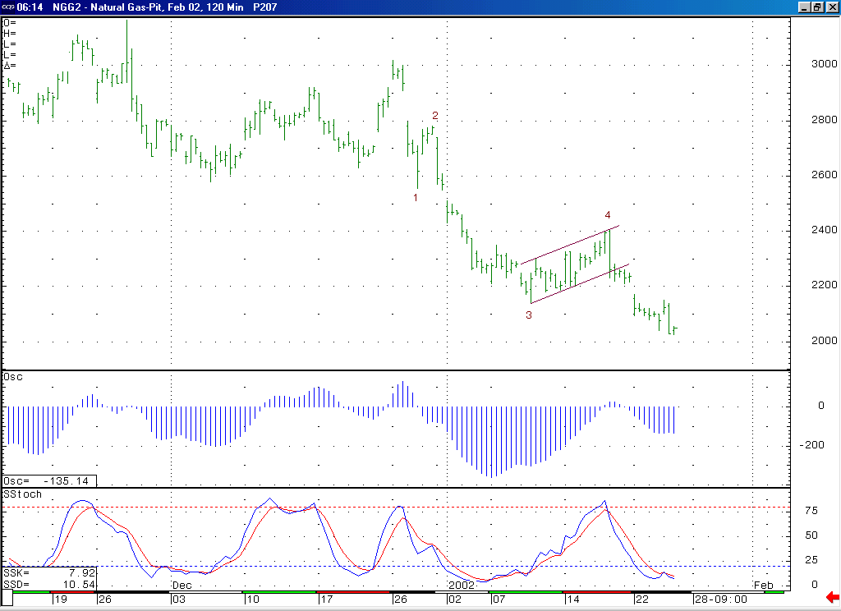
The shape of this 5-35 oscillator continues to suggest that the current decline off of 2.405 is occurring in a minor degree wave 5 position. If this is the case, then this decline should be followed by a rather substantial short covering rally once it has concluded.
The market has now reached down very near our target in the 2.00 area. If it is going to continue pressing lower in the next few days, then it will likely need to do this in a rather direct manner in order to avoid loosing its downward momentum (due to the current near term oversold state shown here on this stochastic).

Technical Discussion: We continue to view the current decline (off of the 2.405 high) as most likely occurring in a minor degree wave 5 position. And the market has now been able to move down very near our ideal target for this wave 5, which is located in the 2.00 area. However, we do continue to see a possibility for the market moving substantially below this 2.00 area as it heads into the expiration of the Feb contract, possibly even all the way back down to retest the 1.76 low made as the October contract was expiring. If this decline is in fact occurring in a wave 5 position, then it should be followed by a more significant short covering rally once it has concluded (the fact that the “funds” are at last report carrying an extraordinarily large net short position can set the market up for such an occurrence in the weeks ahead). We believe that if the market can get well below the 2.00 area on its current leg of weakness, then this would enhance the prospects for such a large short covering rally after this decline has concluded.

The information herein is believed to be reliable, however Capstone Trading Advisors Inc. does not warrant its completeness or accuracy. The opinions and estimates contained constitute our judgment and are subject to change without notice. Past performance is not indicative of future results. The information contained herein is not intended as an offer or solicitation for the purchase or sale of any financial instrument or commodities. Chart provided with permission from CQG Inc.

