12-Step Guide for Dialing into Work with your Laptop

- Plug-in regular analog phone line into modem in laptop.
Do not use a digital phone line. i.e. Office Phones

- Power on laptop and wait for prompt to use “Docked Configuration” or “Undocked Configuration.”

- Select “Undocked Configuration.”

- Once login screen comes up, hit “Control-Alt-Delete” and login using the local account and domain.
Domain usually in format “ECT-000000” or “ECTSF-000000”
- When login finishes, double-click on the “Dial-Up Networking” icon on the desktop to open the following window. Make sure the phone number will work for you according to your location.
Dial-Up Networking also found under “Start-Programs-Accessories-Dial Up Networking”

Hotel/Work Environment – Enter a “8,” or “9,” before the number
Home Environment – Keep number at “7134283098”
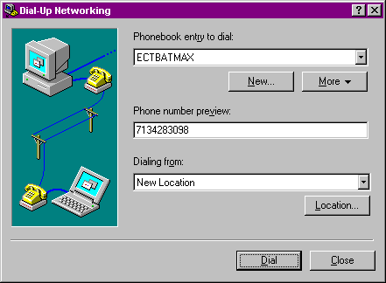
To Disable Call-Waiting – Commonly enter a “*70,” before the number

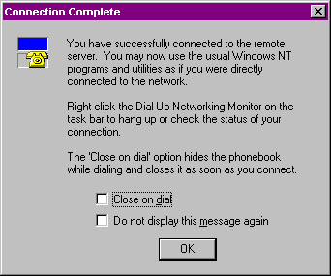
- Select “Dial” and supply your normal network user-id and password. DO NOT TYPE IN A DOMAIN AND DO NOT SELECT SAVE PASSWORD CHECKBOX. Wait for the connection to be established and then select “OK.”

- Double-click on the “Remote Application Manager” icon on desktop to bring up the following window.
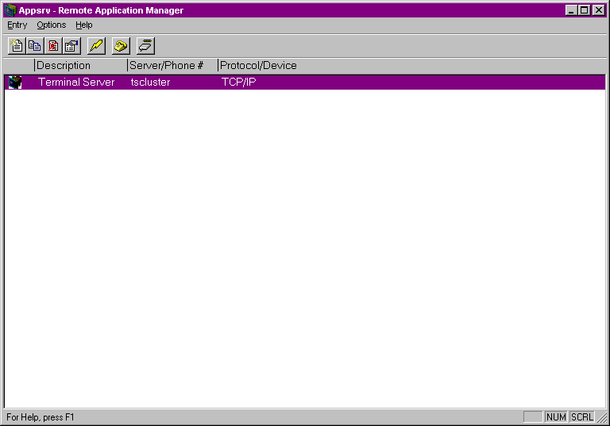
Also found under “Start-Programs-Citrix ICA Client-Remote Application Manager”

- Double-click on “Terminal Server” and wait for connection to establish.

- Once connection is established, the following window will display. Login using your normal network user-id and password for work.
not the undocked user-id and password
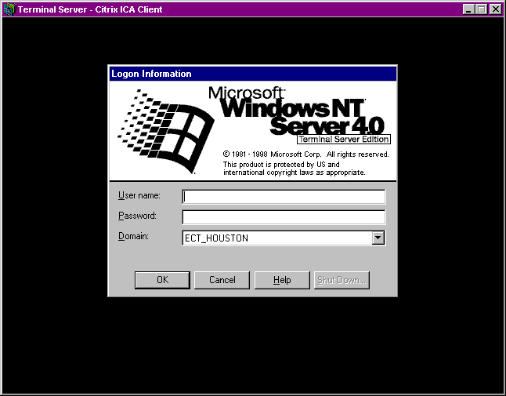
- Once logged in, you will be able to access some applications
you normally use at work. Everyone should be able to run Lotus Notes, Netscape, and basic applications such as the phone book.

11. When you are finished, click “Start – Disconnect” to close the session.

12. To disconnect the modem connection, double-click “Dial-Up Networking” and choose “Hang Up”.

