Capstone Trading Advisors Inc. 830-249-7007

Nat Gas Summary for 12/31/01: The market did in fact begin a short-term bounce on Friday in response to its near term oversold condition. However, this bounce will need to move back above the short-term resistance in the 2.795 to 2.84 area rather quickly in order to regain some of the markets near term bullish footing. As mentioned previously, the size and speed of the recent decline brings forward the possibility for the first time that this short covering rally may have concluded at the recent high of 3.02 (if this is the case, then it would have done so sooner and from a lower price than we had anticipated). This possibility is derived primarily by the depth of the last drop in the Feb contract (getting to a marginal new low), but when looking at the perpetual, the scope of this drop looks much more in line with the idea that this short covering rally will be continuing in the days / weeks that follow (albeit in a more sideways variety than had been previously expected). We expect the subsequent action in the market to help us reconcile the differences in these two charts.

Support: 2.695 2.64 2.555 2.51 2.45 Resistance: 2.795-2.84 2.92 3.02 3.165

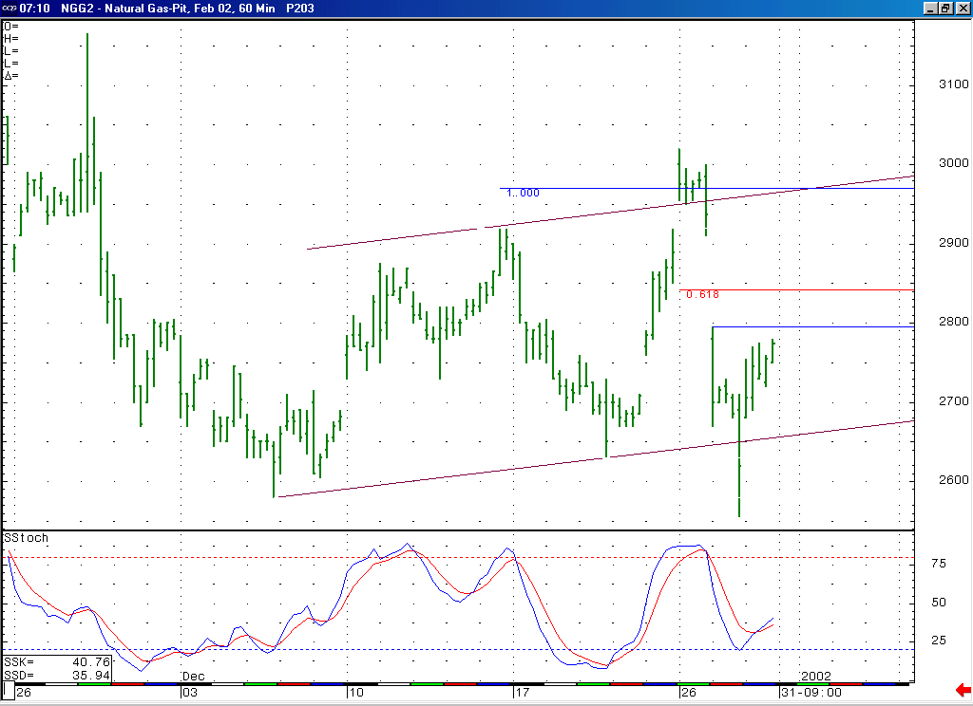
This near term oversold condition did in fact lead to a bounce in the market late last week. However, the market will need to get above this near term resistance in the 2.795 to 2.84 area relatively soon in order to alleviate current concerns that this recent break has signaled the conclusion of the markets short covering rally of the recent weeks.

Technical Discussion: While the recent very sharp drop that occurred (following a sharp move higher) was very much in line with our expectations for very choppy trade at this time, the size of this drop has now brought forward the possibility for the first time that the short covering rally that the market has been unfolding for the past several weeks may have concluded. This possibility is derived by looking at the Feb contract (as opposed to the perpetual which still seems to suggest that a continuation of this short covering rally is more likely). We will need to see the current decline cease to drop in such an accelerated manner (which the market has done a good job of so far), and then get above the short-term resistance in the 2.795 to 2.84 area, to begin to support the case that this short covering rally is still unfolding. If this were to occur, and the market could begin working its way higher again, then we would have to view the recent drop as most likely occurring as the wave B of a flat or expanded flat correction (basis the Feb contract).

The information herein is believed to be reliable, however Capstone Trading Advisors Inc. does not warrant its completeness or accuracy. The opinions and estimates contained constitute our judgment and are subject to change without notice. Past performance is not indicative of future results. The information contained herein is not intended as an offer or solicitation for the purchase or sale of any financial instrument or commodities. Chart provided with permission from CQG Inc.

