Capstone Trading Advisors Inc. 830-249-7007

Nat Gas Summary for 12/28/01: The market had been doing a very nice job of chopping higher in its short covering rally of late. While the sharp drop yesterday that followed an equally sharp rise that preceded it certainly is in keeping with our very choppy expectations, the size of this drop now brings forward the possibility for the first time that this short covering rally may have concluded at the recent high of 3.02 (if this is the case, then it would have done so sooner and from a lower price than we had anticipated). This possibility is derived by the depth of the last drop in the Feb contract (getting to a marginal new low), but when looking at the perpetual, the scope of this drop looks much more in line with the idea that this short covering rally will be continuing in the days / weeks that follow. We expect the subsequent action in the market to help us reconcile the differences in these two charts.

Support: 2.555 2.51 2.45 2.40 2.18 Resistance: 2.67 2.73 2.84 2.92 3.02

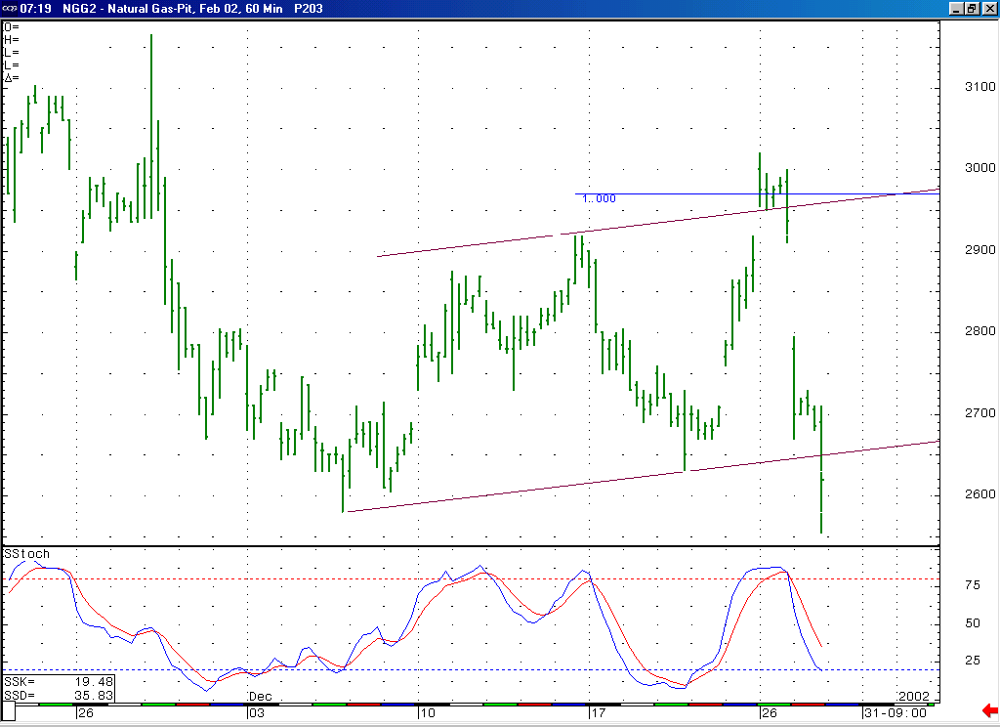
This very sharp and large drop that followed the choppy (corrective shape) move higher brings forward the possibility that this short covering rally ended sooner and from a lower price than we had expected. But even if this is the case, then the market approaching a near term oversold position here should lead to somewhat of a move higher in the near term.

Technical Discussion: While the very sharp drop that occurred yesterday was very much in line with our expectations for a near term pullback in a continued very choppy market, the size of this drop has now brought forward the possibility for the first time that the short covering rally that the market has been unfolding for the past several weeks may have concluded. This possibility is derived more by looking at the Feb contract, as opposed to the perpetual which would still seem to suggest that a continuation of this short covering rally is more likely. In either case, we will need to see the current decline cease to drop in such an accelerated manner to begin to support such a case. If this were to occur, and the market could begin working its way higher again (which looks likely in the near term with the market now moving into a near term oversold position), then the Feb contract can reconcile itself with this scenario that would allow for this short covering rally to continue for another week or two (if this is going to be the case, then we would have to view the current drop as most likely occurring as the wave B of a flat or expanded flat correction).

The information herein is believed to be reliable, however Capstone Trading Advisors Inc. does not warrant its completeness or accuracy. The opinions and estimates contained constitute our judgment and are subject to change without notice. Past performance is not indicative of future results. The information contained herein is not intended as an offer or solicitation for the purchase or sale of any financial instrument or commodities. Chart provided with permission from CQG Inc.

