Capstone Trading Advisors Inc. 830-249-7007

Nat Gas Summary for 12/27/01: The market did continue higher yesterday in a continuation of its short covering rally, however it stalled early in the session right at the key short-term resistance point that we had discussed, in the 2.96 to 3.01 area. This factor coupled with the large distance traveled recently on the upside by the market (leading to its current near term overbought condition) should allow for a pullback in the near term. If this were to occur it would be very much in line with our expectations for this short covering rally unfolding in a very choppy manner. We continue to view the 3.20 to 3.60 area as the most likely target zone for this short cover rally. If this short covering rally does in fact continue to evolve in the days / weeks ahead, as we expect to occur, then this should provide us with a very good longer-term selling opportunity.

Support: 2.87 2.855 2.80 2.75-2.73 2.59 Resistance: 2.99-3.02 3.04 3.12 3.20

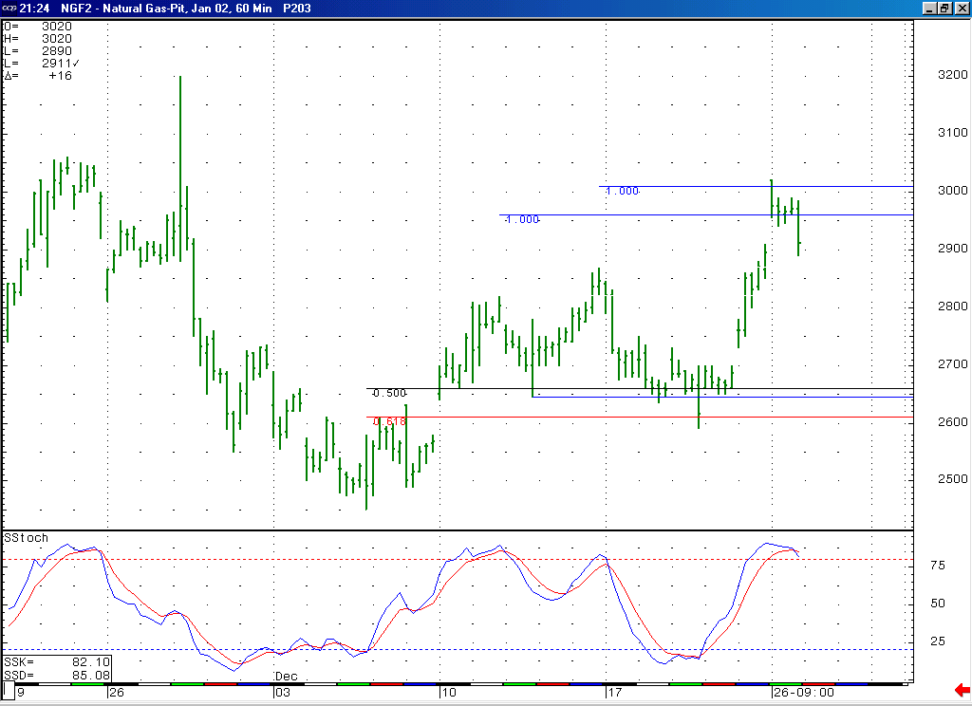
The fact that the market stalled yesterday at this key short-term resistance in the 2.96 to 3.01 area, coupled with the fact that it has now moved into a near term overbought position, should allow for a near term pullback (which would be fitting with our expectations for very choppy trade at this time).

Technical Discussion: We continue to believe that the recent low at 2.45 represents the conclusion of the minor degree wave 5 that we had been anticipating. If we are correct in our assessment that this minor degree wave 5 is also the concluding portion of a larger degree wave 5, then this should now place the market well into the process of unfolding the very large and lengthy short covering rally that we had been expecting to follow this low. This move higher (which is expected to unfold in a very choppy manner) is expected to take at least a month to unfold and target the 3.20 to 3.60 area at minimum. If this short covering rally is going to be able to achieve the lofty targets that we anticipate, then it will likely need some sort of trigger (such as some significantly cold weather occurring) in order for this to occur. If such a trigger does not present itself in this timeframe, then this will likely lead to this short covering rally stalling shy of our targets. In either of these cases however we are viewing this anticipated short covering rally as presenting us with a very good longer-term selling opportunity.

The information herein is believed to be reliable, however Capstone Trading Advisors Inc. does not warrant its completeness or accuracy. The opinions and estimates contained constitute our judgment and are subject to change without notice. Past performance is not indicative of future results. The information contained herein is not intended as an offer or solicitation for the purchase or sale of any financial instrument or commodities. Chart provided with permission from CQG Inc.

