Capstone Trading Advisors Inc. 830-249-7007

Nat Gas Summary for 12/26/01: After holding the good short-term support in the mid to lower 2.60’s, we had expected the market to be left in a position from which it could continue marching higher overall in its short covering rally. And on Friday the market did in fact do just this, reaching up above its recent high. Now that the market has gotten above this recent high at 2.87, a key short-term resistance area is created in the 2.96 to 3.01 area. We continue to believe at this time that the market should have a good chance of reaching up to our stated target zone for this short covering rally between 3.20 and 3.60, but if this is going to occur, then we will need to see the market take out this key short-term resistance fairly soon. If this short covering rally does in fact continue to evolve in the days / weeks ahead, as we expect to occur, then this should provide us with a very good longer-term selling opportunity.

Support: 2.87 2.79 2.75-2.70 2.59 Resistance: 2.91 2.96-3.01 3.04 3.12 3.20

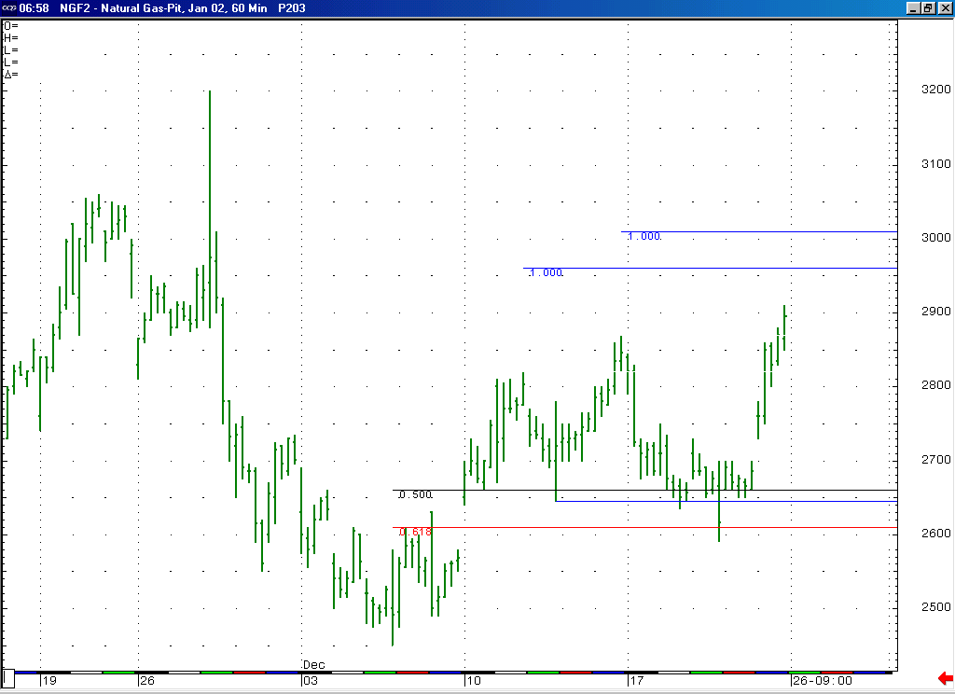
After holding the good short-term support in the mid to lower 2.60’s, the market was in fact able to continue higher as we had expected. With this it has now created a key short-term resistance area here in the 2.96 to 3.01 area.

Technical Discussion: We continue to believe that the recent low at 2.45 represents the conclusion of the minor degree wave 5 that we had been anticipating. If we are correct in our assessment that this minor degree wave 5 is also the concluding portion of a larger degree wave 5, then this should allow for the market to now be in the process of unfolding the very large and lengthy short covering rally that we had been expecting to follow this low. This move higher (which is expected to unfold in a very choppy manner) is expected to take at least a month to unfold and target the 3.20 to 3.60 area at minimum. If this short covering rally is going to be able to achieve the lofty targets that we anticipate, then it will likely need some sort of trigger (such as some significantly cold weather occurring) in order for this to occur. If such a trigger does not present itself in this timeframe, then this will likely lead to this short covering rally stalling shy of our targets. In either of these cases however we are viewing this anticipated short covering rally as presenting us with a very good longer-term selling opportunity.

The information herein is believed to be reliable, however Capstone Trading Advisors Inc. does not warrant its completeness or accuracy. The opinions and estimates contained constitute our judgment and are subject to change without notice. Past performance is not indicative of future results. The information contained herein is not intended as an offer or solicitation for the purchase or sale of any financial instrument or commodities. Chart provided with permission from CQG Inc.

