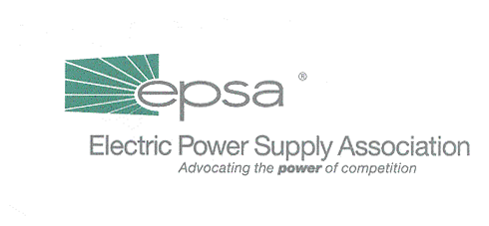
The Washington Summary

When it finally became obvious that there would be no last minute deal on the economic stimulus package, Congress called it a year. The fireworks may have been fun to watch from the outside – there was a last ditch Capitol press conference with the President and a second new, improved, “bipartisan” economic package passed by the House at 4 a.m. For the participants, however, there’s sure to be a very sour aftertaste. You can hope that a month off will put everyone in a better mood when Congress reconvenes in January, but don’t take any bets on it.

For the next two weeks, the Washington Summary will join the rest of Washington in political and practical hibernation. Have a very happy holiday season.

The House – Energy and Air Quality Subcommittee Chairman Joe Barton (R-TX) tried his best, but ultimately had to face the fact that his subcommittee really didn’t want to move electricity legislation in the last days of the session. Our visits to subcommittee members confirmed that a number of usually reliable votes for the chairman were becoming a bit less reliable. The Democrats were surprisingly uniform in their opposition. Throw in end-of-year general grumpiness, lukewarm (at best) outside support for action now and member concerns about Enron, and it’s easy to conclude that the chairman did the right thing by postponing a decision on his bill to another day.

On Tuesday, the subcommittee did officially kick off a markup with opening statements. Knowing that no other action would be taken until February, most subcommittee members were predictably absent. The few that attended offered little in the way of surprises. Barton did announce that there would be another legislative draft which would include new, unspecified language to ensure consumer confidence and address energy trading issues. Rep. John Shimkus (R-IL) noted concern about the RTO provisions (and referenced EPSA testimony) and asked for appropriate changes to the bill.

Chairman Barton and subcommittee Ranking Member Rick Boucher (D-VA) are now confirmed to attend EPSA’s Winter Membership Meeting in Vail.

The Senate – The full Senate Commerce, Science & Transportation Committee held a hearing on the Enron Bankruptcy on Tuesday. Neither the energy industry nor issues specific to our industry were mentioned, and the hearing focused mostly on 401(k)s, with some attention given to SPEs (special purpose entities) and auditor independence.
It is becoming increasingly clear that the Enron bankruptcy could lead to new rules governing corporate retirement plans and accounting practices.

Senator Craig Thomas (R-WY), a member of the Senate Energy and Natural Resources Committee, and Bob Simon, majority Staff Director of the Energy and Natural Resources Committee, are now confirmed to attend the Winter Membership Meeting.

The Bush Administration – The Treasury Department ruling on the taxation of merchant power interconnection assets is expected on December 26. We have circulated an analysis of the draft ruling and will notify members of any changes.

EPA is still talking about rolling out its proposal to reform NSR. While they evidently have finalized their plan to make administrative changes to the program, it is not clear how this plan will be unveiled. The Administration is still undecided whether to link announcement of its NSR revisions to its soon-to-be proposed multi-emissions bill (which is projected to be out before January’s end).

Also joining us at Vail will be Stephen Wright, Acting Administrator of the Bonneville Power Administration.

KEY DATES

The Legislative Affairs Committee has tentatively scheduled two briefings for Congressional staff: on January 28, to discuss developments in the competitive wholesale marketplace and the impact of the Enron bankruptcy; and on February 11, to discuss RTO development and recent FERC policies.
Jan. 8 – Accounting Working Group conference call at 2:00 p.m. EST.
Jan. 10 – Legislative Affairs Committee weekly conference call/meeting at 3:00 p.m. EST.

To access all Legislative Affairs Committee, Tax Policy Working Group and Accounting Working Group Conference Calls, dial 1-800-937-6563 and ask for the EPSA call moderated by Gene Peters.

