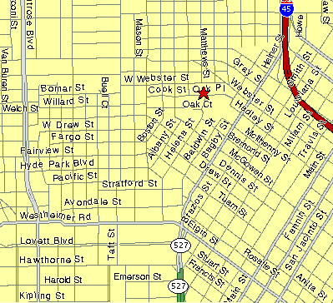

128 Oak Place – Three story White Stucco Townhouse
Phone # 713-533-0882

If you are Coming From 45 North, 59 North, I-10 East or West, and 290 get to
45 and go south to the Dallas/Pierce Exit, this is the exit on the right lane of the Freeway once you are at downtown. Once you exit stay on the exit ramp until you get to the Bagby St. exit and go right on Bagby through 2 lights and then take a Right on Hadley, first street after the 2nd light. Once on Hadley take the first left and that is Oak Place go a couple hundred yards and you will see the white stucco townhouses on the right. Park where you can on the street. Our front door faces the street.

From 59 south head north, exit downtown/Brazos, this exit turns into Brazos St.
Take Brazos to Hadley and take a left, go through one stop sign and then take the first left and that is Oak Place go a couple hundred yards and you will see the white stucco townhouse on the right. Park where you can. There is no light at Hadley so if you miss it just go left on West Gray then left on Bagby then take a Right on Hadley.

From 45 South Exit Scott St / Downtown and take the St Joseph Street Exit.
Stay on St Joseph Street until you get to Smith, you have to go all the way through downtown, and take a left on Smith and then a right on West Gray and a left on Bagby then take a Right on Hadley, first street after the 2nd light. Once on Hadley take the first left and that is Oak Place go a couple hundred yards and you will see the white stucco townhouse on the right. Park where you can.

From 288 well Brian just call me if you are coming to the party.

