Capstone Trading Advisors 210-527-9960

Thursday November 30, 2000

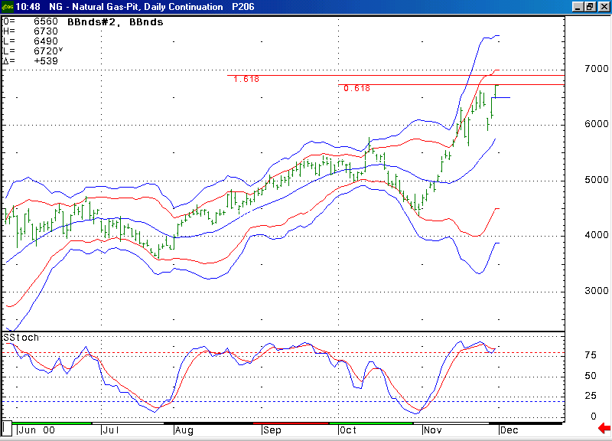
The market gapped above 6.50 resistance and then was able to hold this spot on the early morning pullback. As expected this opened the door for a retest of the 6.725 to 6.815 target area.

We anticipated that the recent minor pullback in the market would likely be concluded when it cleared yesterday’s reactionary high at 6.50. In continuing with its theme of extreme volatility, the market was able to gap open clear of this area this morning. We expect that clearing this area would allow for a retest of the target in the 6.725 to 6.815 area. The fact that the market held 6.50 on its early morning retest affirmed this thought. In the near-term we would expect this 6.725 to 6.815 area to again keep somewhat of a lid on the market. However, we do think that the market can exceed this area in the days ahead (if it can be supported by continued cold weather in the forecast). Once above this area there should not be much in the way of overhead resistance until the market reaches the 7.30 area.

The information herein is believed to be reliable, however Capstone Trading Advisors does not warrant its completeness or accuracy. The opinions and estimates contained constitute our judgment and are subject to change without notice. Past performance is not indicative of future results. The information contained herein is not intended as an offer or solicitation for the purchase or sale of any financial instrument or commodities. Chart provided with permission from CQG Inc.

