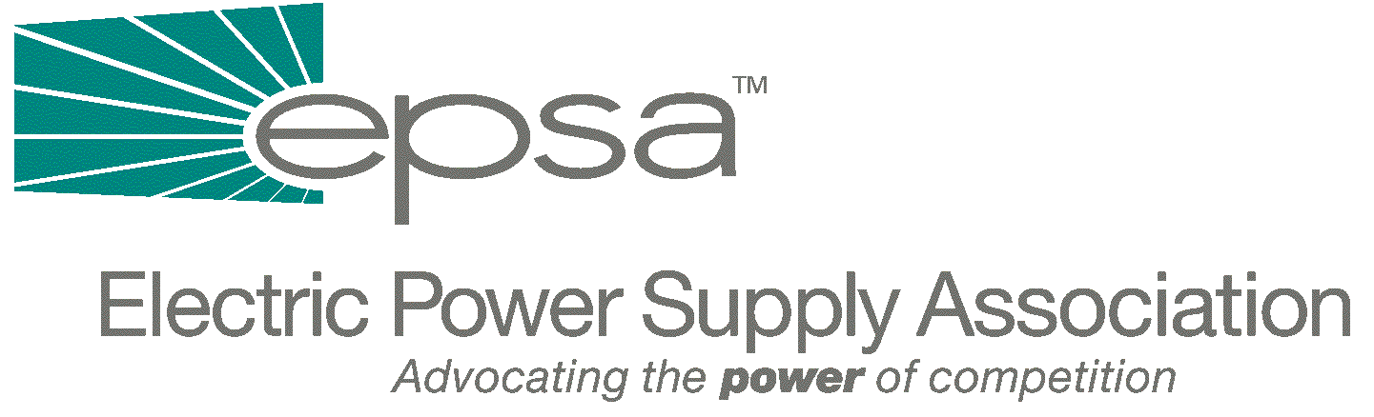
1401 New York Avenue, NW
11th Floor
Washington, DC 20005
202/628-8200
202/628-8260 fax
www.epsa.org
Memorandum

TO: | EPSA Legislative Affairs Committee
FROM: | Scott A. Weiner, Legislative Affairs Committee Chair  Eugene F. Peters, Vice President of Legislative Affairs
DATE: | November 27, 2001
RE: | Conference Call: Legislative Affairs Committee Conference Call/Meeting This Thursday, November 29, at 3:00 p.m., EST.

We will hold a Legislative Affairs Committee Conference Call/Meeting this Thursday, November 29, at 3:00 p.m. EST. The call/meeting will be held at EPSA (1401 New York Avenue, 11th Floor). To access the call, dial 1-800-937-6563 and ask for the EPSA call moderated by Gene Peters.
Among the issues to be discussed are:
- Outlook for the remaining days of the Congressional session:
- Discussion of the current House and Senate legislative agenda;
- Preparation for meeting with House Energy and Commerce staff. This meeting will take place in room 316 of the Ford Building at 4:15 pm, immediately after our Call/Meeting. If you plan to attend this meeting with House Energy and Commerce staff and have not yet told Donn Salvosa (dsalvosa@epsa.org), please do so.
- Discussion of EPSA legislative strategy and focus.
- Planning for EPSA December 11 Strategy session and Winter Membership Meeting

