Capstone Trading Advisors Inc. 830-249-7007

Nat Gas Summary for 11/27/01: We had been looking for the market to move lower in the near term, to test the support in the 2.68 to 2.63 area at minimum. While the market got only marginally below the lower end of this short-term support in the 2.63 area yesterday, the swiftness with which it moved down to this area now makes it much less likely that this support will continue to contain the current decline. If the market is now able to break through this important short-term support in the 2.68 to 2.63 area, and especially if it can do this in a rather sharp manner, then as we have discussed this should set it up to continue on to new lows (below 2.50) in the days that follow. Below the 2.50 area, we continue to view the next valid target area (and what should be good support) clustered in the 2.40 to 2.30 range.

Support: 2.655 2.61 2.58 2.50 2.40-2.30 Resistance: 2.735 2.78 2.88 2.95-3.02

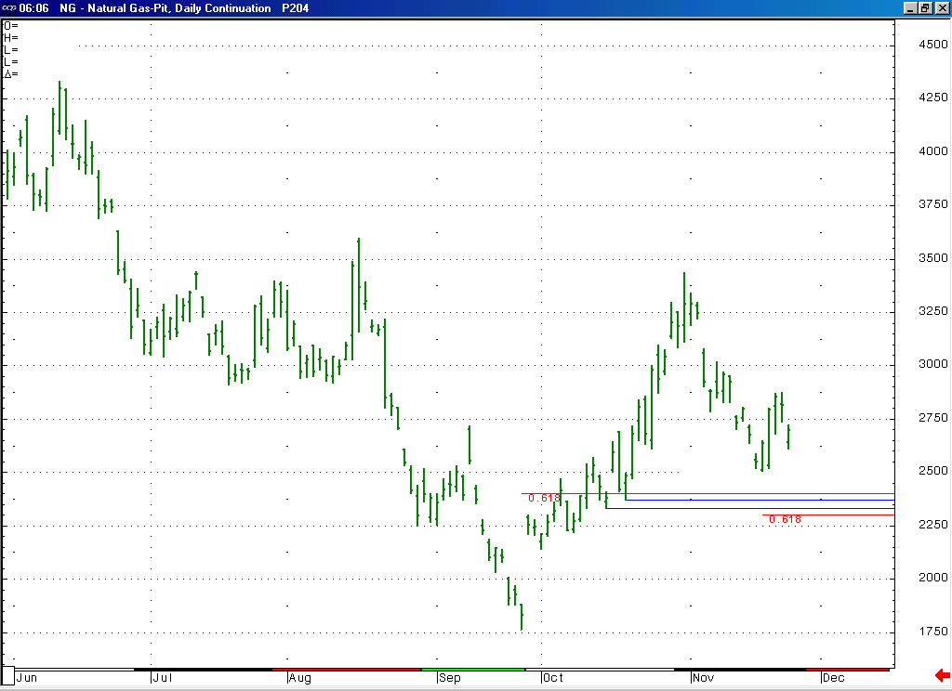
If the market does move on to new lows in the next couple of sessions, which is looking more likely, then we would expect this move to target, and likely be contained by, the good support here in the 2.40 to 2.30 area. This target / support is derived using the December contract as well as the perpetual (the perpetual is pictured here).

Technical Discussion: The question at hand has been whether the recent bounce was a minor degree countertrend move (that was swifter and carried further than was ideal, as has been the case quite often in the recent months), or if this turn around was enough to signify that the recent low (that met only our minimal objectives in getting marginally below the previous low at 2.535) was the significant low that we have been anticipating. The key to answering this question was to be derived by the market pulling back to test the important short-term support in the 2.68 to 2.63 area. We did in fact get this anticipated pullback yesterday. And while the market has yet to get materially below this support area, the speed with which it moved down to this area (and not having corrective characteristics) now makes it much less likely that this area will hold the current decline in check. As mentioned, if the market can soon break through this important short-term support, and especially if it can do this in an impulsive manner, then this should quickly shift the odds in favor of the first scenario mentioned above, which would leave it in a position to continue on to new lows (below 2.50) in the near term. While we would expect this anticipated move to new lows to carry down to the target (and good support) in the 2.40 to 2.30 range, we would be surprised to see the December contract getting below this area prior to its expiration.

The information herein is believed to be reliable, however Capstone Trading Advisors Inc. does not warrant its completeness or accuracy. The opinions and estimates contained constitute our judgment and are subject to change without notice. Past performance is not indicative of future results. The information contained herein is not intended as an offer or solicitation for the purchase or sale of any financial instrument or commodities. Chart provided with permission from CQG Inc.

