Capstone Trading Advisors 210-527-9960

Monday November 27, 2000

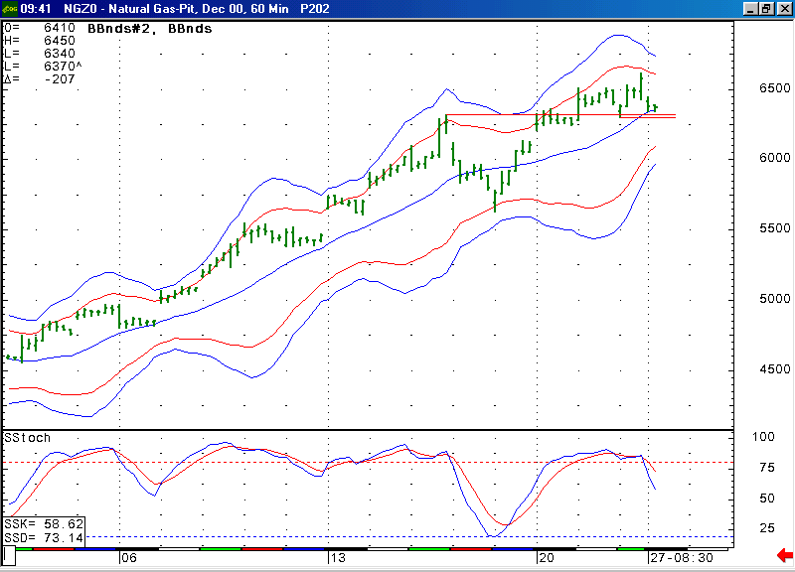
The market has now moved down to test its first support in the 5.30 area. As you can see here, this area also contains this 20 period average. If the market were to get materially below this area, then this would likely open the door for it to follow through down to the area of its lower Bollinger bands shown here.

The information herein is believed to be reliable, however Capstone Trading Advisors does not warrant its completeness or accuracy. The opinions and estimates contained constitute our judgment and are subject to change without notice. Past performance is not indicative of future results. The information contained herein is not intended as an offer or solicitation for the purchase or sale of any financial instrument or commodities. Chart provided with permission from CQG Inc.

