Capstone Trading Advisors Inc. 830-249-7007

Nat Gas Summary for 11/26/01: We continue to look for the market to be moving lower in the near term, after being held in check late last week by the good resistance in the 2.95 to 3.02 area. At minimum, we expect this decline to consolidate last week’s rather sharp gains off of the recent low at 2.50. If the market is going to add credibility to the idea that this 2.50 low is one of significance, then we will need to see this anticipated decline unfolding in a slow and choppy manner, and holding near the important short-term support in the 2.68 to 2.63 area. There is still a slight chance that the market could exceed last weeks low at 2.50. If this is going to be the case, then we are going to need to see the market moving lower in an accelerated manner very soon (slicing through the support in the 2.68 to 2.63 area in short order).

Support: 2.735 2.68 2.63 2.58 2.50 Resistance: 2.88 2.95-3.02 3.085 3.24

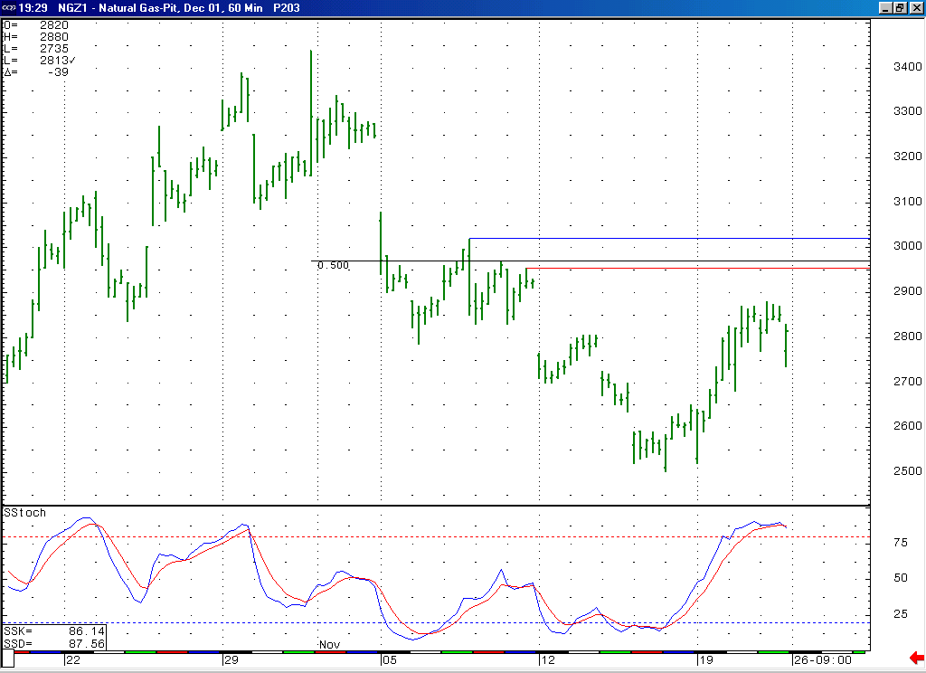
We expect this good overhear resistance in the 2.95 to 3.02 area coupled with the markets near term overbought condition to allow for it to be moving lower in the near term.

Technical Discussion: With the market having recently moved down to new lows (below 2.535) it had met our minimum expectations for concluding its wave 5 decline (which began from the 3.44 high). The manner in which the market has reversed sharply back to the upside off of the recent low at 2.50 would suggest that there is now a decent chance that this low that we were anticipating is now in place. In order to build confidence in this possibility we will need to see the next significant weakness in the market (which we are expecting in this timeframe) unfolding in a clearly corrective manner. If this is going to be the case, then we would ideally expect to see such a corrective pullback respecting the important short-term support in the 2.68 to 2.63 area. We do still however see a possibility that this wave 5 is still in the process of unfolding (which would mean that the last bounce carried further than was ideal, which has not been unusual for this market in recent months). In order to further this case, we will instead need to see the market moving lower in a very accelerated manner at this time, taking out this important short-term support in the 2.68 to 2.63 area in rather short order. Such action would set the market up to head into its expiration this week in a very defensive manner (making new lows below 2.50 at minimum).

The information herein is believed to be reliable, however Capstone Trading Advisors Inc. does not warrant its completeness or accuracy. The opinions and estimates contained constitute our judgment and are subject to change without notice. Past performance is not indicative of future results. The information contained herein is not intended as an offer or solicitation for the purchase or sale of any financial instrument or commodities. Chart provided with permission from CQG Inc.

