Capstone Trading Advisors Inc. 830-249-7007

Nat Gas Summary for 11/21/01: The market did in fact move materially above the good short-term resistance in the 2.83 area yesterday, which increases the chances that the low that we have been anticipating is already in place at last weeks low of 2.50. However, even if the low were in place, we would expect the market to soon get some sort of a pullback in order to relieve its short-term overbought condition. In this regard we would be quite surprised to see the current leg of strength carry the market above the good resistance in the 2.95 to 3.02 area. We would expect such a pullback to carry the market back down toward the 2.60’s at minimum. If the market is going to renew the possibility of visiting the 2.50 low again, then it will be necessary for it to soon slice materially through what should now be important short-term support in the 2.68 to 2.64 area.

Support: 2.73 2.68 2.64 2.58 2.50 Resistance: 2.87 2.95-3.02 3.085 3.24

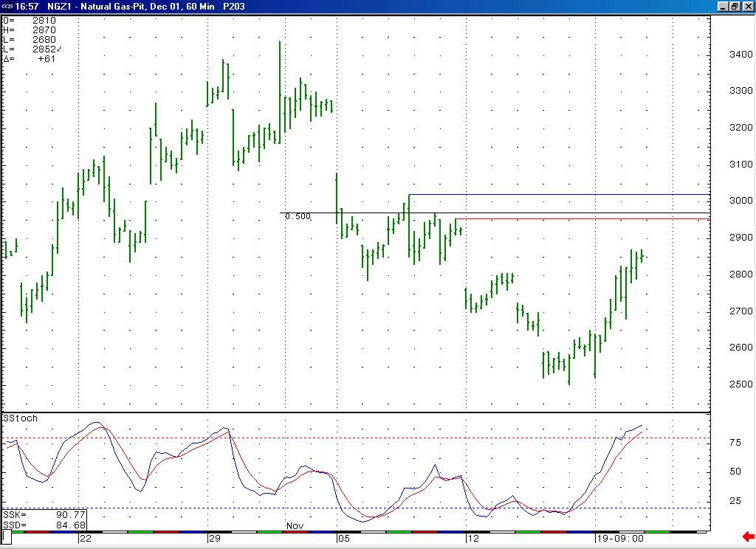
We would be quite surprised to see the current leg of strength carry the market above what should be good short-term resistance here in the 2.95 to 3.02 area. In addition we would expect this push higher to soon give way to a pullback, given its current near term overbought position (as witnessed here by this 14-bar stochastic.

Technical Discussion: With the market having moved down to new lows (below 2.535) late last week it had met our minimum expectations for the wave 5 decline unfolding off of the 3.44 high, and with that had moved itself into a position from which we were expecting this decline to conclude relatively soon. With the market having moved up off of the 2.50 low rather quickly this week, and taking out the good short-term resistance in the 2.83 area in the process, there is now a fair body of evidence to support the idea that this wave 5 concluded last week at 2.50. The next significant test of whether or not the market has already put in our anticipated low will come when it displays its next significant weakness (which we would expect to occur relatively soon). If it were to follow this recent impulsive looking push higher with a clearly corrective pullback that at this point would be expected to hold in the mid 2.60’s (as opposed to following this sharp push higher with a similarly sharp move back lower as this market has been accustomed to doing in the recent months), then this would build an even stronger case for last weeks low at 2.50 being one of high significance.

The information herein is believed to be reliable, however Capstone Trading Advisors Inc. does not warrant its completeness or accuracy. The opinions and estimates contained constitute our judgment and are subject to change without notice. Past performance is not indicative of future results. The information contained herein is not intended as an offer or solicitation for the purchase or sale of any financial instrument or commodities. Chart provided with permission from CQG Inc.

