Capstone Trading Advisors Inc. 830-249-7007

Nat Gas Summary for 11/20/01: In moving to new lows late last week (below 2.535) the market has now met our minimum expectations for this decline. Once this minimum target had been met, we had mentioned the need to be very cautious of the market reversing back to the upside in this timeframe. The sharp move higher yesterday certainly brings to the forefront the possibility that the market has now put in the low that we have been anticipating. If the market were to now get materially above the good short-term resistance in the 2.785 to 2.83 area, then this would enhance this possibility even further. But the real test of whether the market has put in a significant low or not will come when the market undergoes its next significant weakness. This market has had a habit of late of undergoing rather sharp and sizeable bounces within its ongoing upward trend, and then continuing on lower in a similarly sharp manner again. It will likely now take this type of action to alleviate the mounting concerns that this leg of the downtrend has concluded.

Support: 2.65 2.63-2.615 2.565 2.50 Resistance: 2.785-2.83 2.87 2.95-3.02 3.085

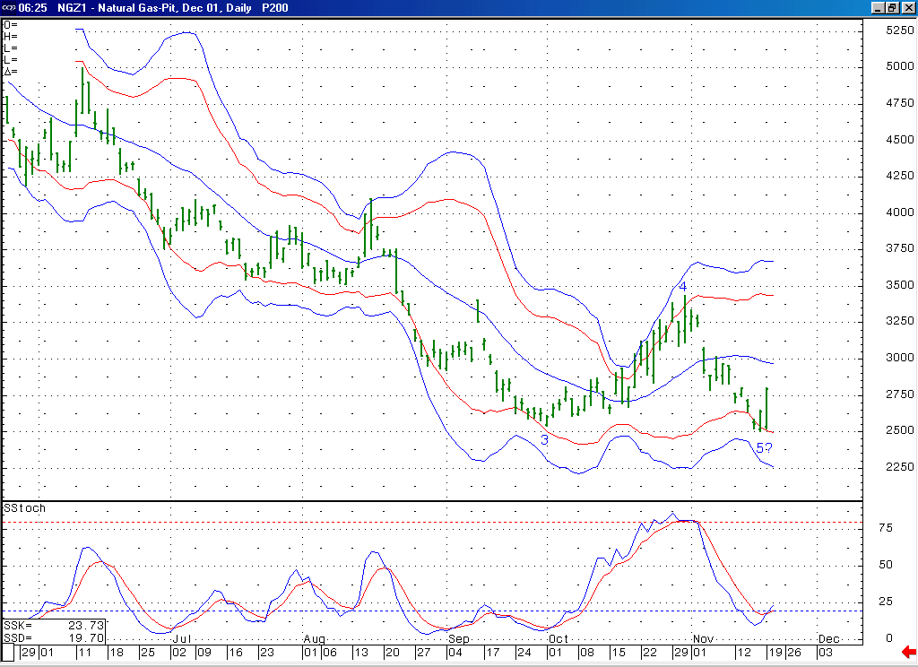
Notice that not only is this 14-day stochastic now beginning to turn up from its oversold position, but in doing so is also creating a bullish momentum divergence as well. Such a divergence is characteristic of the conclusion of a wave 5.
With the market having met its minimum requirements late last week for the conclusion of this wave 5, we then witnessed a rather sharp reversal back to the upside yesterday. This is the first sign that would suggest that this wave 5 might have in fact concluded. Getting above this 20-day average would further such a case.

Technical Discussion: With the market having moved down to new lows (below 2.535) late last week it had met our minimum expectations for the wave 5 decline unfolding off of the 3.44 high, and with that had moved itself into a position from which we were expecting this decline to conclude relatively soon. The first such sign that this wave 5 may have concluded occurred yesterday, when we witnessed a sharp reversal back to the upside. The real test of whether or not the market has already put in our anticipated low or not will come when it displays its next significant weakness. If it were to follow this recent impulsive looking push higher with a clearly corrective pullback that at this point would be expected to hold in the mid to lower 2.60’s (as opposed to following this sharp push higher with a similarly sharp move back lower as this market has been accustomed to doing in the recent months), then this would build a strong case for last weeks low at 2.50 being one of high significance.

The information herein is believed to be reliable, however Capstone Trading Advisors Inc. does not warrant its completeness or accuracy. The opinions and estimates contained constitute our judgment and are subject to change without notice. Past performance is not indicative of future results. The information contained herein is not intended as an offer or solicitation for the purchase or sale of any financial instrument or commodities. Chart provided with permission from CQG Inc.

