Capstone Trading Advisors Inc. 830-249-7007

Nat Gas Summary for 11/19/01: In moving to new lows late last week (below 2.535) the market has now met our minimum expectations for this decline. We continue to view this move lower as giving us a good opportunity to scale out (in both time and price) of short positions. Below the 2.535 area we have an expected target for this decline located in the 2.40 to 2.30 area. At this point we believe that there is still a good chance that the market should reach down toward this target area. If the market can reach down to this target area relatively soon, then we would be out of a majority of short positions at that point. We continue to expect this decline to conclude relatively soon.

Support: 2.58 2.50 2.47 2.40-2.30 2.22 Resistance: 2.65 2.70 2.785-2.83 2.87

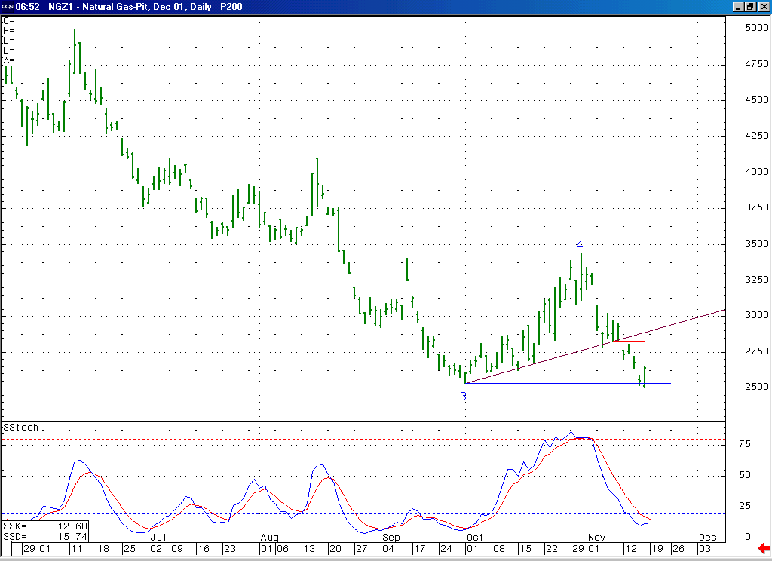
With the market now being in a quite oversold state (not to mention the fact that this 14-bar stochastic has a chance to create a bullish momentum divergence if it turns up soon), we continue to believe that if it is going to reach down to our lower targets (in the 2.40 to 2.30 area) it is going to need to do this in a rather direct manner in order to avoid loosing its downward momentum.
With this wave 5 having met its minimum target of moving to new lows late last week, we must now be very cautious of it reversing back to the upside at any point now. If the market were to get above the important short-term resistance in the 2.785 to 2.83 area, then this would be a good indication that such a reversal has occurred.

Technical Discussion: We continue to view the current decline off of the 3.44 high as occurring in a larger degree wave 5 position. With the market having moved down below its early October low at 2.535 late last week (as was anticipated) it has now met our minimum expectations for this decline. While we do expect the market to continue moving lower in the days that follow (toward its next expected target in the 3.40 to 3.30 range), now that it has moved into these new lows we must be very cautious of the potential for it reversing back to the upside at any point now. This is the reason that we prefer exiting short positions on a scale out basis during this timeframe, as opposed to trying to pick the exact time and location of the anticipated bottom. We continue to view the 2.00 area as being the likely maximum target for this decline (we do not expect the market to make it down this low, unless this were to occur concurrently with the expiration of the December contract). This wave 5 scenario calls for this decline to give way to a substantial and sustained move back to the upside once it has concluded. We expect this decline to most likely be concluding relatively soon.

The information herein is believed to be reliable, however Capstone Trading Advisors Inc. does not warrant its completeness or accuracy. The opinions and estimates contained constitute our judgment and are subject to change without notice. Past performance is not indicative of future results. The information contained herein is not intended as an offer or solicitation for the purchase or sale of any financial instrument or commodities. Chart provided with permission from CQG Inc.

