Capstone Trading Advisors Inc. 830-249-7007

Nat Gas Summary for 11/14/01: At this time we continue to believe that the current decline (off of the 3.44 high) should be carrying the market down to new lows (below 2.535) in the days / weeks that follow. If the market is going to remain in its best near term bearish position, then we will want to see bounces remaining slow and choppy (the market has done a good job of this to this point), and we would prefer to not see the market getting materially above the short-term resistance in the 2.83 to 2.865 area at this time. If the market can soon get below Monday’s low at 2.70, it should not encounter much in the way of significant support below here until the 2.535 area (the early October low).

Support: 2.74 2.70 2.625 2.535 2.40-2.30 Resistance: 2.83-2.865 2.90 2.98 3.02

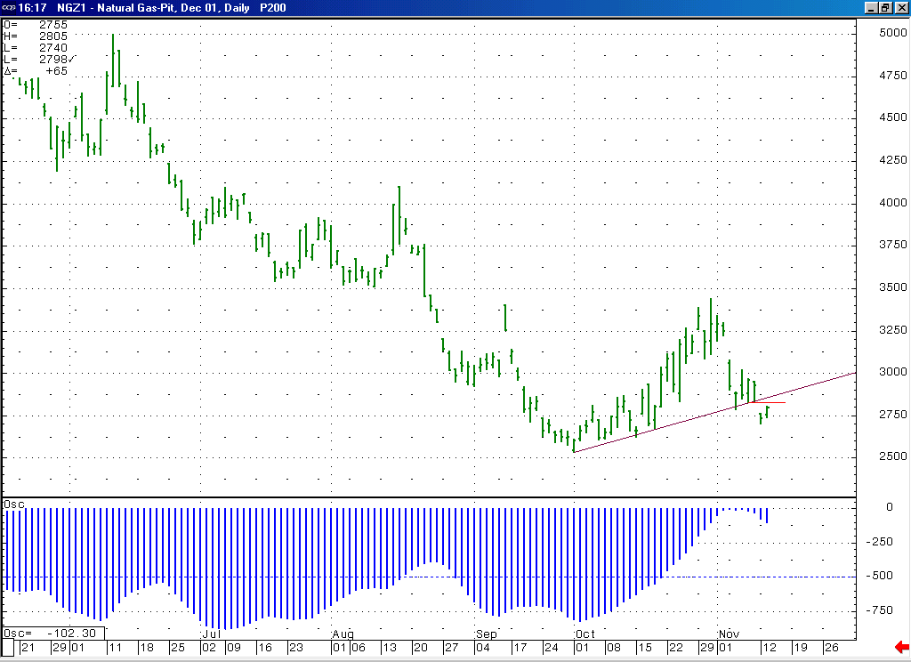
If the market is in fact currently unfolding a larger degree wave 5 (as is supported by the shape of this 10-70 oscillator), then we should see this oscillator making and concluding a smaller trough as this wave 5 plays out.
After its recent bearish break down on Monday, it would be best to see the market now be contained by the short-term resistance in the 2.83 to 2.865 area, which contains the recent break down point, as well as the underside of this recently broken trend line).

Technical Discussion: We continue to believe that the extremely choppy rise off of the early October low has occurred as a large correction, most likely in a larger degree wave 4 position (as opposed to a leading diagonal triangle). The market having moved down off of its recent high at 3.44 in such an impulsive manner, as well as the bounces within this overall decline maintaining corrective characteristics supports this near term bearish outlook. In order to enhance the markets bearish potential, we will want to see any such bounces continue to maintain their corrective form. In this regard, we would prefer to see the current small bounce off of Monday’s low at 2.70 remaining for the most part below the short-term resistance in the 2.83 to 2.865 area (this area contains the short-term break down point, as well as the underside of the recently broken trend line). If the market is in fact moving lower in a larger degree wave 5 at this time, then this decline should carry the market in an impulsive manner below its previous low (at 2.535) at minimum. Below here we have an intermediate target in the 2.40 to 2.30 area, and a maximum expected target in the 2.00 area. We would be extremely surprised to see this decline make a new low on the perpetual chart (the 1.76 low made by the October contract as it expired). We expect this decline to most likely be concluding relatively soon (in the next week or two).

The information herein is believed to be reliable, however Capstone Trading Advisors Inc. does not warrant its completeness or accuracy. The opinions and estimates contained constitute our judgment and are subject to change without notice. Past performance is not indicative of future results. The information contained herein is not intended as an offer or solicitation for the purchase or sale of any financial instrument or commodities. Chart provided with permission from CQG Inc.

