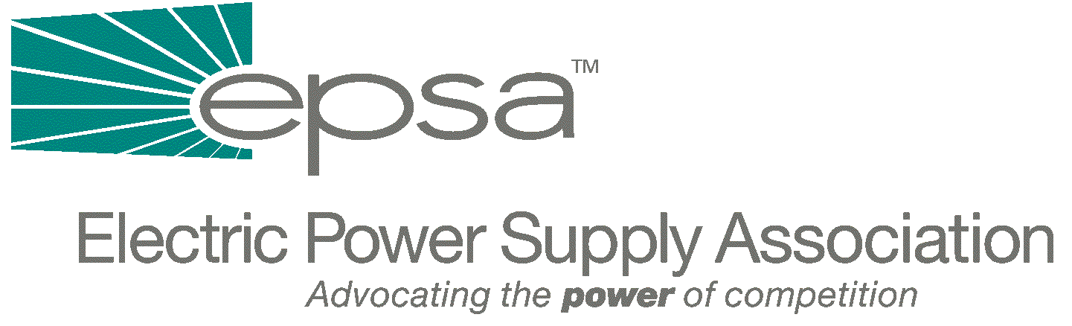

1401 New York Avenue, NW
11th Floor
Washington, DC 20005
202/628-8200
202/628-8260 fax
www.epsa.org

Memorandum
TO: | EPSA Legislative Affairs Committee
FROM: | Scott A. Weiner, Legislative Affairs Committee Chair  Donn J. Salvosa, Manager of Government Affairs
DATE: | September 28, 2025
RE: | New England Congressional Delegation Letter to FERC on Northeast RTO Governance Structure

While some of you may already have seen press reports on this matter, attached is a letter which members of the New England Congressional delegation, lead by Rep. Ed Markey (D-MA), sent to FERC Chairman Pat Wood on Thursday. The letter highlights the delegation’s concerns surrounding the composition of the region’s RTO Board.
However, it is important to note that the discussions of the letter center on the composition of the Board, and not whether the Board should or should not exist. The letter was signed by 23 members from both parties. If you have any questions, please contact Gene Peters (gpeters@epsa.org) or Donn Salvosa (dsalvosa@epsa.org) at (202) 628-8200.
Attachment

