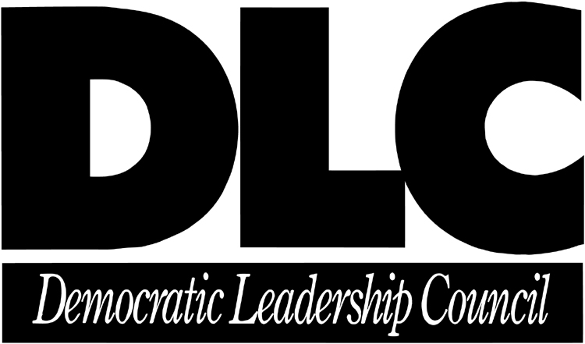

SAVE THE DATE

DLC’s Capitol Hill Lunch Series

FEATURING:

Baltimore Mayor Martin O’Malley

Al From, DLC Founder & CEO

What: November Capitol Hill Lunch

When: Thursday, November 8, 2001

Time: 12:00 P.M. – 1:30 P.M.

Where: DLC Offices
600 Pennsylvania Avenue, SE
Suite 400
Washington, DC

Mayor O’Malley will discuss Baltimore’s pioneering efforts in emergency preparedness and home front readiness. For more information please see the following website address: http://www.msnbc.com/news/639814.asp

If you would like to attend, please RSVP with your name, organization, and telephone number to the DLC receptionist at (202) 546-0007.

If you have any questions regarding the event, please ask for Tawney Bains.

We look forward to seeing you there!

